Document 1: Petition to President Truman
July 3, 1945
A PETITION TO THE PRESIDENT OF THE UNITED STATES
We, the undersigned scientists, have been working in the field of atomic power for a number of years. Today … we feel impelled (encouraged) to say what follows:
The war has to be brought speedily to a successful conclusion and the destruction of Japanese cities by means of atomic bombs may very well be an effective method of warfare. We feel, however, that such an attack on Japan could not be justified in the present circumstances. We believe that the United States should not resort to the use of atomic bombs in the present phase of the war, at least not unless the terms which will be imposed upon Japan after the war are publicly announced and subsequently Japan is given an opportunity to surrender.
Atomic bombs are primarily a means for the ruthless annihilation (destruction) of cities. Once they were introduced as an instrument of war it would be difficult to resist for long the temptation of putting them to such use.
Atomic power will provide the nations with new means of destruction. The atomic bombs at our disposal represent only the first step in this direction and there is almost no limit to the destructive power, which will become available in the course of this development. Thus a nation which sets the precedent of using these newly liberated forces of nature for purposes of destruction may have to bear the responsibility of opening the door to an era of devastation on an unimaginable scale.
We respectfully petition that you rule that the United States shall not, in the present phase of the war, resort to the use of atomic bombs.
Leo Szilard and 58 co-signers

Document 2: Leaflet dropped on Japanese cities by the American military
TO THE JAPANESE PEOPLE:
America asks that you take immediate heed of what we say on this leaflet.
We are in possession of the most destructive explosive ever devised by man. A single one of our newly developed atomic bombs is actually the equivalent in explosive power to what 2,000 of our giant B-29's can carry on a single mission. This awful fact is one for you to ponder and we solemnly assure you it is grimly accurate.
We have just begun to use this weapon against your homeland. If you still have any doubt, make inquiry as to what happened to Hiroshima when just one atomic bomb fell on that city.
Before using this bomb to destroy every resource of the military by which they are prolonging this useless war, we ask that you now petition the Emperor to end the war. Our President has outlined for you the thirteen consequences of an honorable surrender: We urge that you accept these consequences and begin the work of building a new, better, and peace-loving Japan.
You should take steps now to cease military resistance. Otherwise, we shall resolutely employ this bomb and all our other superior weapons to promptly and forcefully end the war.
EVACUATE YOUR CITIES
Document 3: President Truman’s radio address
A Warning to Japan Urging Surrender: Excerpts from President Truman's radio address to the American people, August 9, 1945
The British, Chinese, and United States Governments have given the Japanese people adequate warning of what is in store for them. We have laid down the general terms on which they can surrender. Our warning went unheeded; our terms were rejected. Since then the Japanese have seen what our atomic bomb can do. They can foresee what it will do in the future.

The world will note that the first atomic bomb was dropped on Hiroshima, a military base. That was because we wished in this first attack to avoid, insofar as possible, the killing of civilians. But that attack is only a warning of things to come. If Japan does not surrender, bombs will have to be dropped on her war industries and, unfortunately, thousands of civilian lives will be lost. I urge Japanese civilians to leave industrial cities immediately, and save themselves from destruction.

I realize the tragic significance of the atomic bomb.

Its production and its use were not lightly undertaken by this Government. But we knew that our enemies were on the search for it. We know now how close they were to finding it. And we knew the disaster, which would come to this Nation, and to all peace-loving nations, to all civilization, if they had found it first.

That is why we felt compelled to undertake the long and uncertain and costly labor of discovery and production.

We won the race of discovery against the Germans. Having found the bomb we have used it. We have used it against those who attacked us without warning at Pearl Harbor, against those who have starved and beaten and executed American prisoners of war, against those who have abandoned all pretense of obeying international laws of warfare. We have used it in order to shorten the agony of war, in order to save the lives of thousands and thousands of young Americans.

We shall continue to use it until we completely destroy Japan's power to make war. Only a Japanese surrender will stop us.

Document 4: Eyewitness account (and photo) of the atomic bombing of Hiroshima, Japan
Ms. Akiko Takakura was 20 years old when the bomb fell. She was in the Bank of Hiroshima, 300 meters away from the hypocenter. Ms. Takakura miraculously escaped death despite over 100 lacerated wounds on her back. She is one of the few survivors who was within 300 meters of the hypocenter. She now runs a kindergarten and she relates her experience of the atomic bombing to children.
Many people on the street were killed almost instantly. The fingertips of those dead bodies caught fire and the fire gradually spread over their entire bodies from their fingers. A light gray liquid dripped down their hands, scorching their fingers. I, I was so shocked to know that fingers and bodies could be burned and deformed like that. I just couldn't believe it. It was horrible. And looking at it, it was more than painful for me to think how the fingers were burned, hands and fingers that would hold babies or turn pages, they just, they just burned away. For a few years after the A-bomb was dropped, I was terribly afraid of fire. I wasn't even able to get close to fire because all my senses remembered how fearful and horrible the fire was, how hot the blaze was, and how hard it was to breathe the hot air. It was really hard to breathe. Maybe because the fire burned all the oxygen, I don't know. I could not open my eyes enough because of the smoke, which was everywhere. Not only me but everyone felt the same. And my parts were covered with holes.

Thermal Radiation Burns of Atomic Bombing Victims
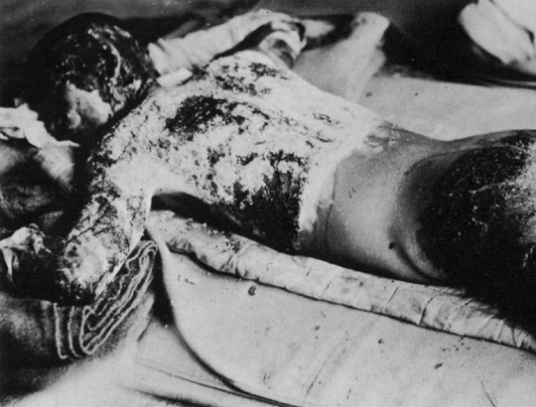

Document 5: Statement from Secretary of War after the atomic bomb was dropped
"The face of war is the face of death; death is an inevitable part of every order that a wartime leader gives. The decision to use the atomic bomb was a decision that brought death to over a hundred thousand Japanese...
"But this deliberate, premeditated destruction was our least abhorrent alternative. The destruction of Hiroshima and Nagasaki put an end to the Japanese war. It stopped the fire raids, and the strangling blockade; it ended the ghastly specter of a clash of great land armies. In this last great action of the Second World War we were given final proof that war is death."
—Secretary of War Henry Stimson
Document 6: Article from the Nippon Times (Japan) after the atomic bomb was dropped
"How can a human being with any claim to a sense of moral responsibility deliberately let loose an instrument of destruction which can at one stroke annihilate an appalling segment of mankind? This is not war: this is not even murder; this is pure nihilism. This is a crime against God and humanity which strikes at the very basis of moral existence. What meaning is there in any international law, in any rule of human conduct, in any concept of right and wrong, if the very foundations of morality are to be overthrown as the use of this instrument of total destruction threatens to do?"
— Nippon Times (Tokyo), August 10, 1945

