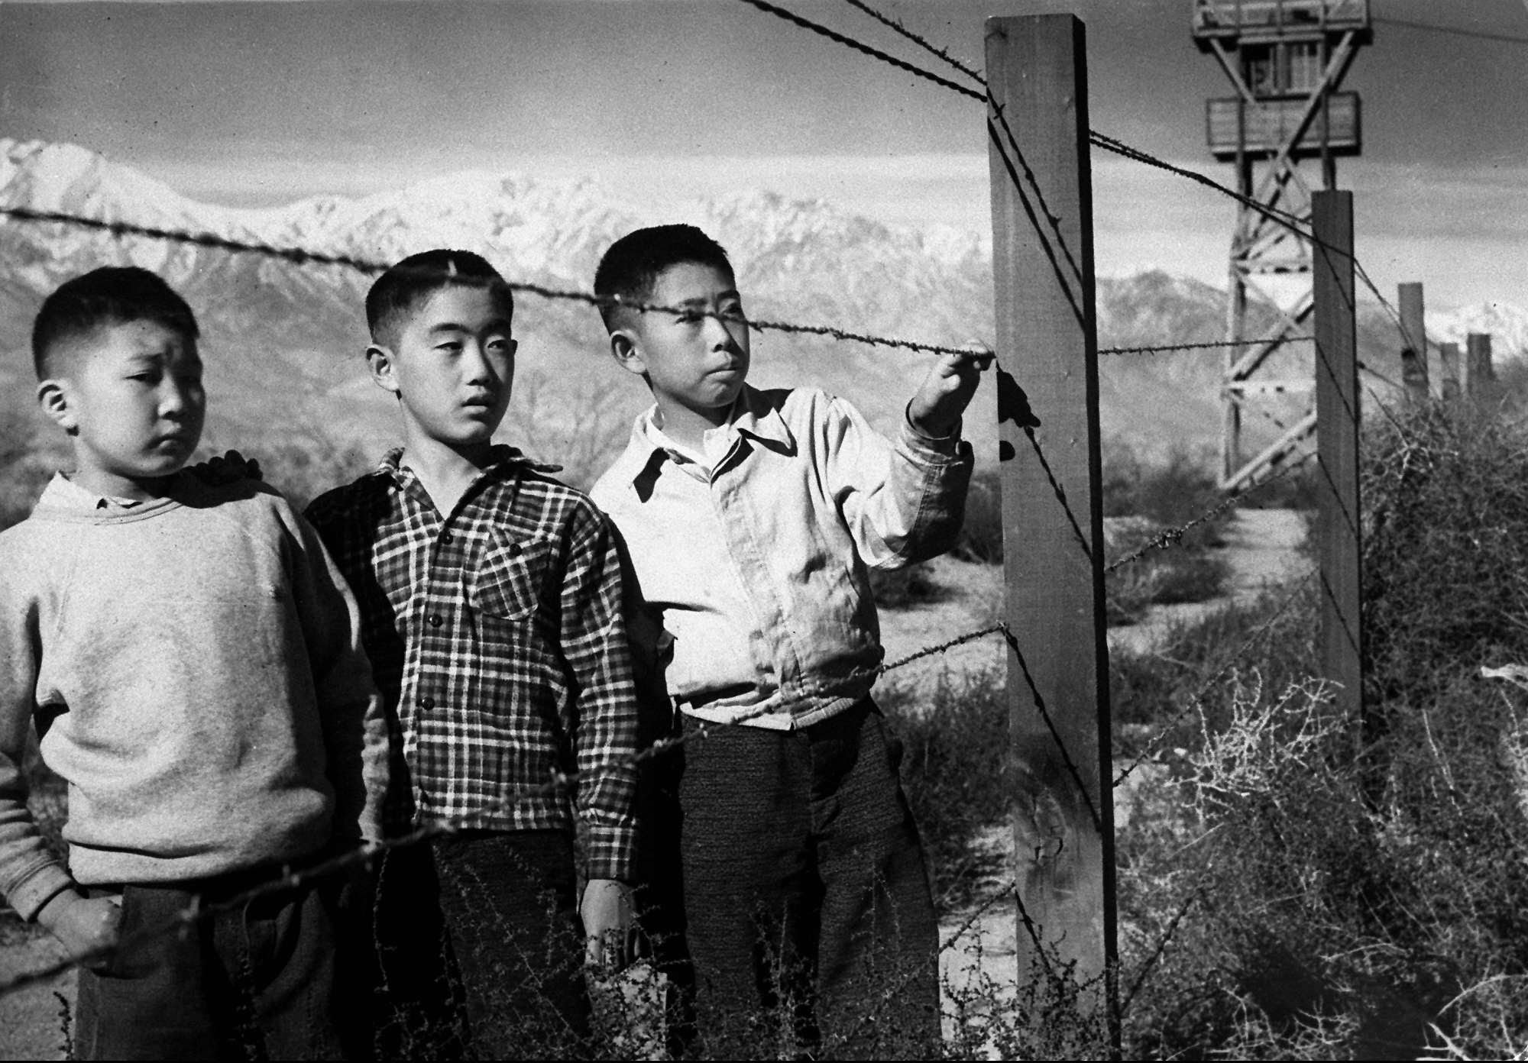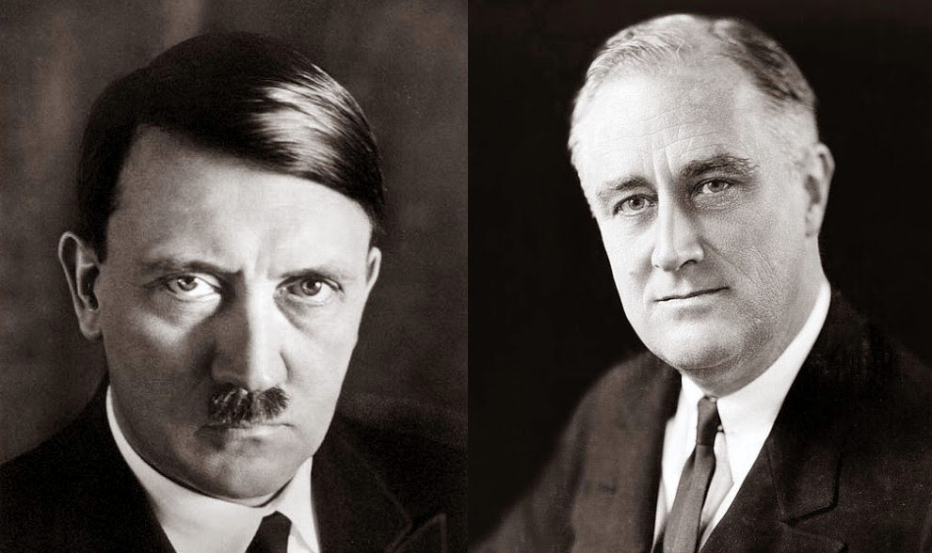
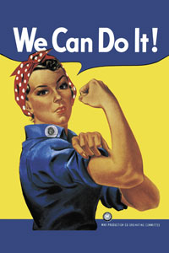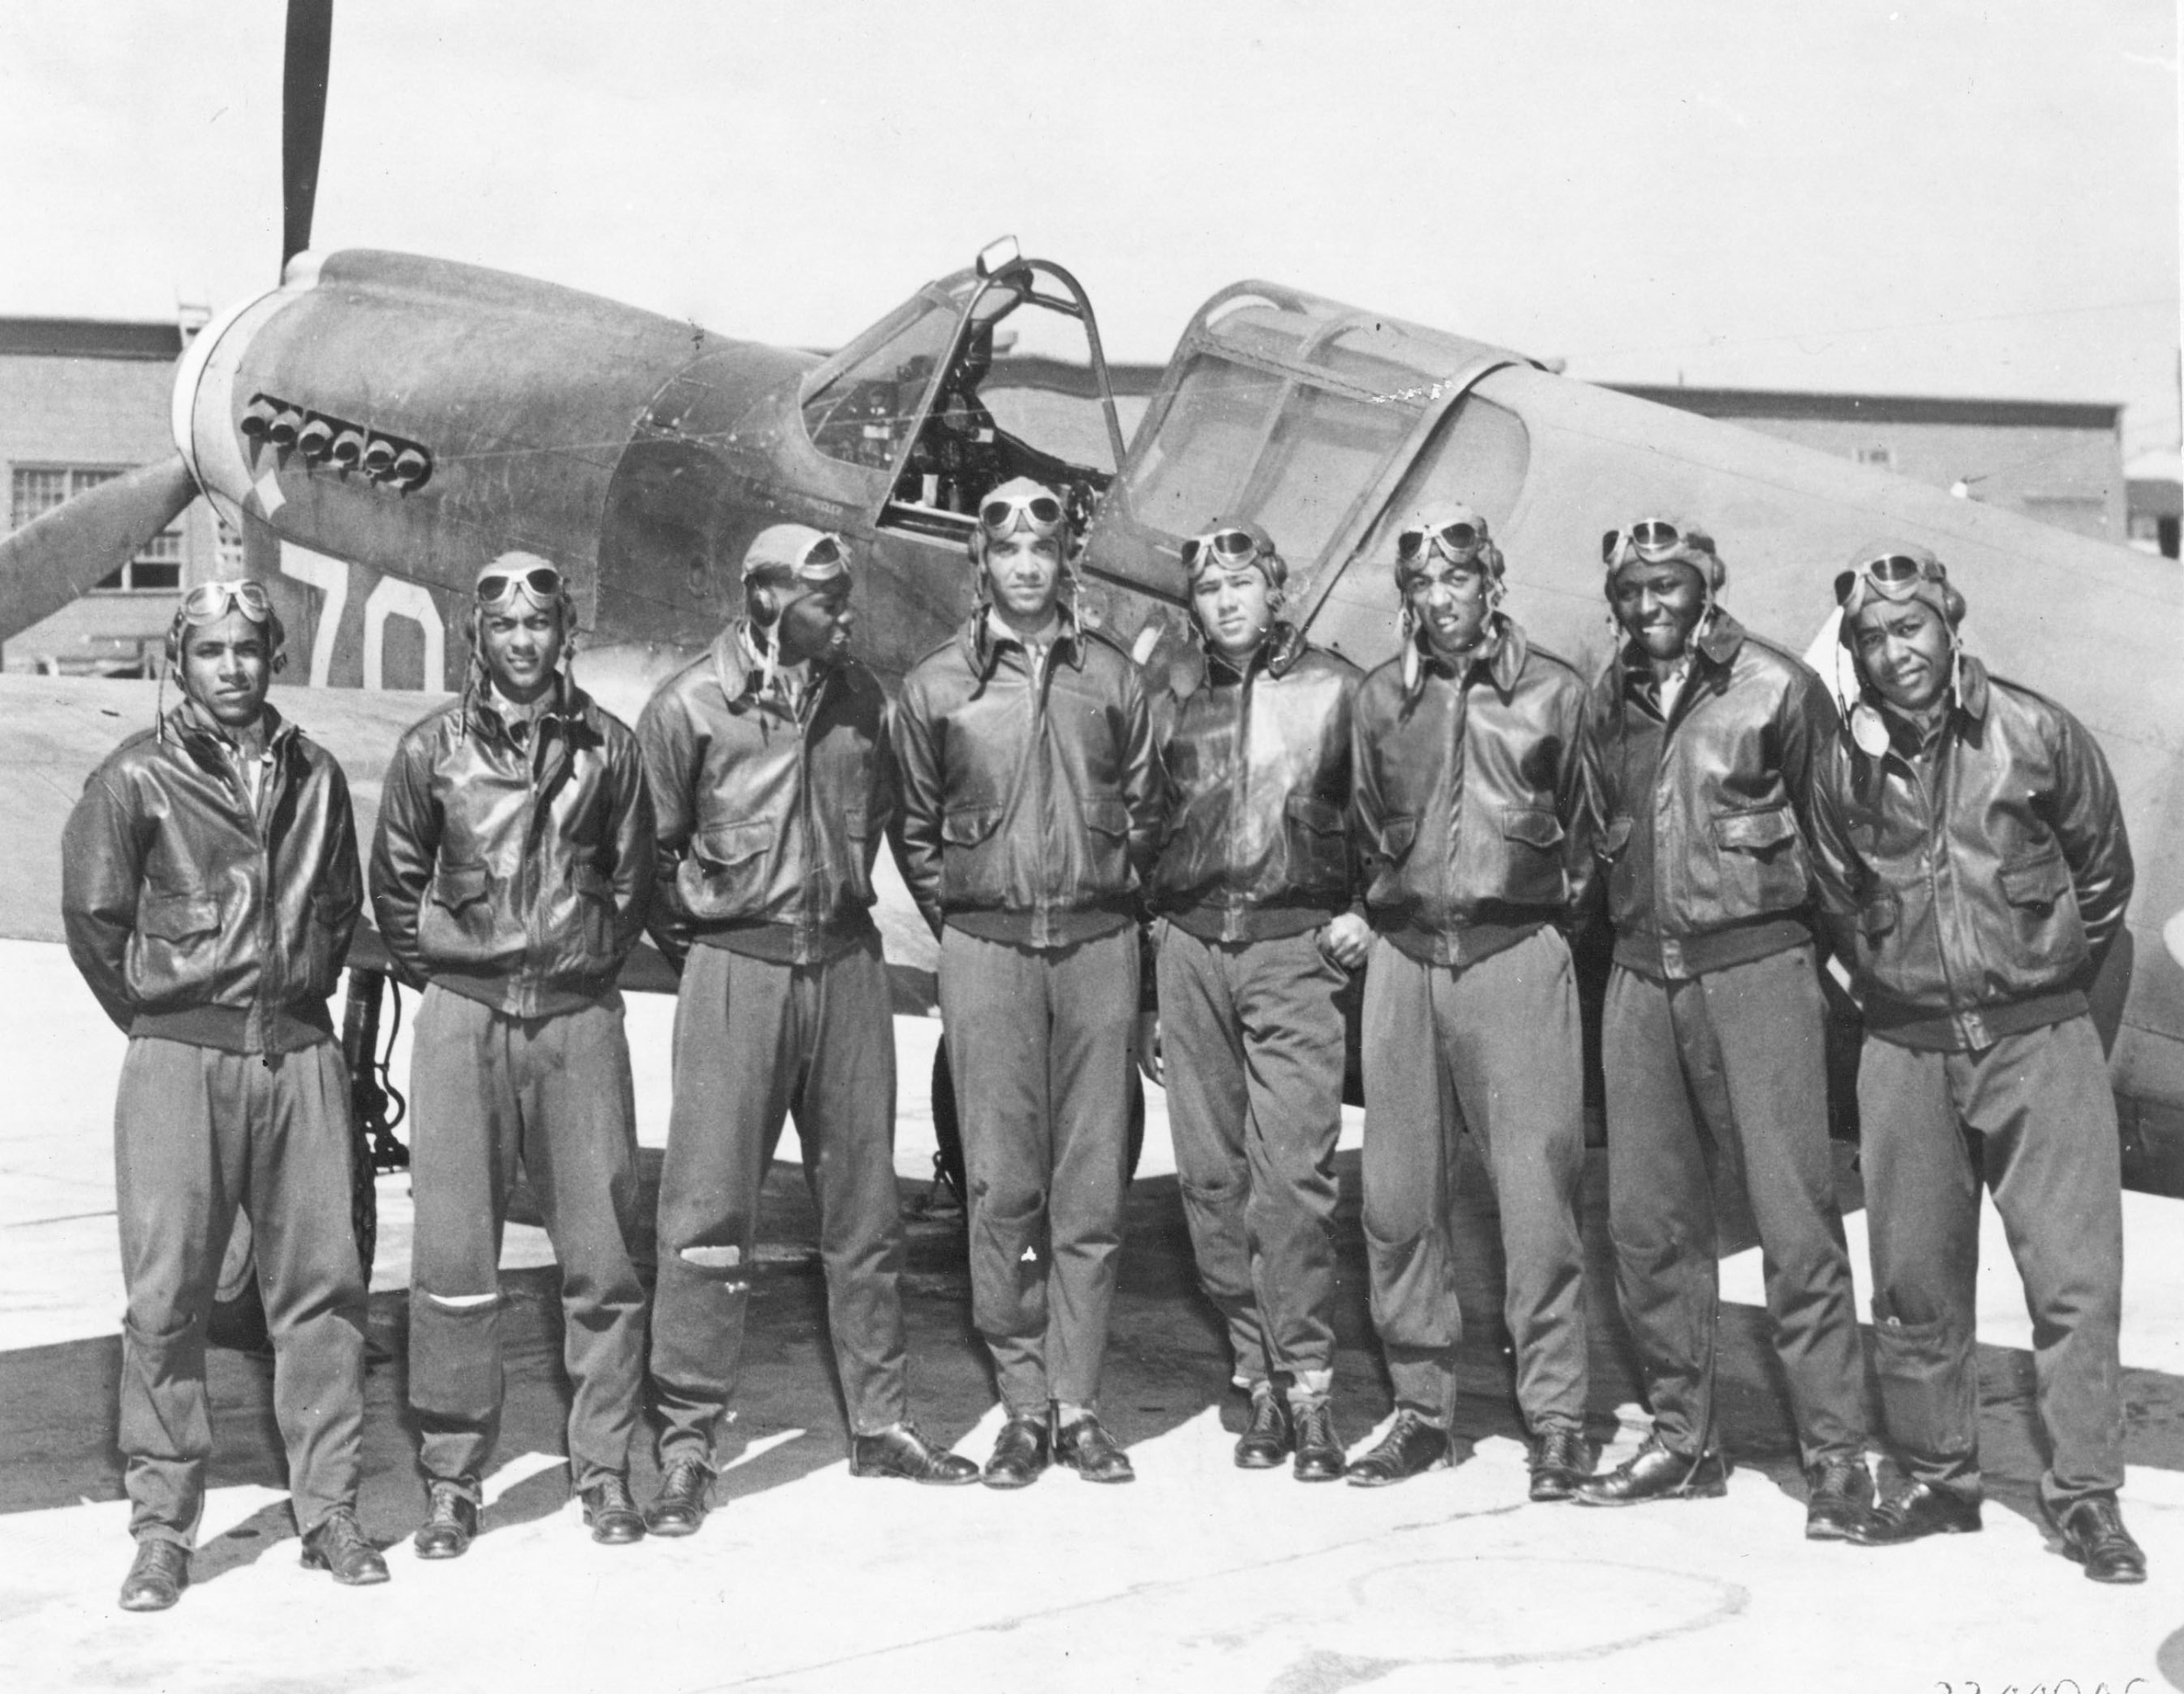
The Many Voices of World War II

By: Allegra Penny
1st Period US History

Table of Contents
Page Title Page Number

Japanese American Internment: Was it the right solution? 1

Role of Minorities in the War: Interview with a Navajo Code Talker 2

American Foreign Policy Then and Now: How do we protect ourselves? 3

Dropping the Atomic Bomb: Making the decision 4

Glossary 5

Japanese-American Internment
Japanese-American internment describes the period from February 1942 until late 1945, when the Roosevelt administration removed over 100,000 Japanese-Americans from their homes and relocated them to camps in the United States. The direct cause of internment was the Japanese sneak attack on Pearl Harbor, on December 7, 1941. The Japanese-American population was high on the West Coast, and many Americans in that region began to get nervous about the threat of spies and saboteurs. There were many rumors that Japanese-American farmers were planting their crops in a way that pointed to military bases or that they were trying to send radio messages to the Japanese. Ultimately, nothing was ever proved. In response to this paranoia, President Roosevelt signed Executive Order 9066 in February of 1942. This gave military commanders jurisdiction to create military zones and exclude potential threats, namely Japanese Americans. By mid-1942, over 100,000 were forcibly removed from their homes and transported to internment camps, where many of them spent the war. After two Supreme Court rulings (Korematsu vs. US and Ex parte Endo) in December 1944, the exclusion order was rescinded, and camps closed later that year. Although internment was over, the effects lingered and are still felt today.
Was internment the right choice?
Internment was a harsh and unnecessary response by the United States government. In fact, even the United States government, who was responsible for this policy, knew it did not work.
In this letter, the Secretary of the Interior describes how the camps are having an unintended effect. Although they are removing potential enemies from mainstream society, many of these Japanese-Americans are becoming “a hostile group.” Instead of solving a problem, the camps created one. Japanese-Americans who had previously been loyal were no longer happy with the United States. It was an extremely hurtful decision with far-reaching implications.

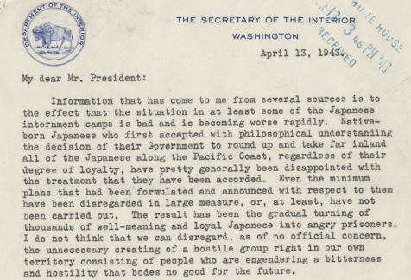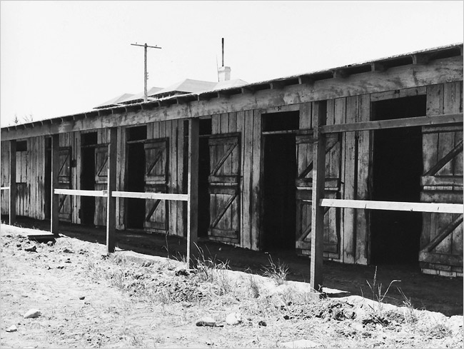
Although the act of interning Japanese-Americans was offensive enough, the conditions were also terrible. This photo may look unremarkable because it is a photo of horse stalls. However, these became the homes of families at Tanforan, one of the camps. Families lived in cramped conditions, without running water or bathrooms in their “homes.” At a basic level, internment was degrading and cruel. Internment was not the right decision. The living standards were so humiliating and they angered Japanese-Americans so much, that the government even realized it was not the right choice.

Ickes, Harold L. Letter to Franklin D. Roosevelt. 13 April 1943.
Lange, Dorothea. “Horse stalls at Tanforan that were turned into living quarters for internees.” 1942. New York Times, 16 February 2017, http://www.nytimes.com/2006/11/06/arts/design/06lang.html

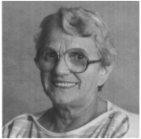
Women in World War II
Women were an integral part of World War II. Although they served in many different roles, you can see women behind every American success in World War II. Women served in three different spheres. Some women joined the military, and although none were allowed into combat, they filled other roles, in such organizations as WAVES, WAAC, and WASP. Many women jumped into the jobs that men left behind in the factories. America’s wartime production was gigantic, and this directly impacted the soldiers’ efforts overseas. Some women remained at home, but they served in other capacities: rationing, planting victory gardens, selling war bonds, and training to defend their homes against potential invaders. Whatever the role, women were active in the nation’s wartime life. These new roles also gave women a feeling of independence and pride in their contributions, and this changed the way women viewed themselves even after the war had ended.

Eileen Hughes

How were you involved in the war effort?
Although I wanted to join WAAC, the women’s branch of the Army, I was too young when I graduated high school. Instead, I volunteered for Civilian Defense and got training for air raids and plane spotting.

How did the war affect your feeling of safety?
Since we were on the coast, people feared that submarines would be sent to attack us. We also had to make sure our curtains were closed for blackouts, so enemy planes couldn’t see us. However, we also felt that we wouldn’t really be attacked because the United States was so powerful.

Did you interact with soldiers at all?
I volunteered at USO dances, which were held on the weekends. These were an opportunity for soldiers stationed in the area to have fun and relax when they weren’t on duty. Soldiers would also check that you were following curfew and blackout regulations.

US Foreign Policy: Then and Now
Leading a country isn’t an easy job, and presidents often have to make tough decisions. One of the toughest is deciding how to protect people inside your borders while also being responsive to those outside who need help.

FDR’s refugee policy
FDR inherited a policy that was enacted nearly a decade before he took power. In 1924, the US adopted the 1924 Immigration Act. This created a quota system, limiting the number of refugees who could come from each country. The quota was based upon the population of each group that was living in the United States at that point. This system persisted through the beginning of World War II, and it restricted German and Austrian immigration to about 35,000 per year, a tiny number compared to demand. The State Department also reinforced many regulations that made it hard to even fill the quota. FDR didn’t intervene until he was asked to by Jewish leaders, many of whom had family in Europe. Initially, FDR himself expressed suspicion of refugees and fears that they could be spies even though he knew of the threat of Hitler. However, he faced pressure from Jewish community members, and eventually he created the War Refugees Board. The WRB aimed to help all refugees fleeing Hitler and accomplished most of its success through diplomatic means. Ultimately, the WRB is estimated to have saved 200,000 lives, yet over 6 million died in the Holocaust. I believe that Roosevelt could’ve done much more to help refugees.

Trump’s refugee policy
Although Donald Trump is a relatively new president, he has made his views on refugees very clear. He has blamed refugees, from both Latin America and the Middle East for terror attacks and a dangerous environment within the United States. He acted on his comments in January 2017 when he signed a travel ban, which many believe is actually a ban on Muslims. Trump argues that it is not, but it targeted those from seven predominantly Muslim countries. It shut down the refugee program temporarily and indefinitely stopped Syrian refugees from entering the US. There was a huge outcry when the ban was put into place, and a judge has blocked Trump’s second attempt at a ban, which removes Iraq from the list. I think that Trump’s refugee policy is discriminatory and does not make us safer. In fact, I think he risks angering people around the country, which could endanger the lives of Americans. America is a diverse country, and it is against our principles to shut out those that are different.

How do we balance keeping our country safe with our responsibility to help those who need it?
I believe that part of the strength of our country is acceptance of those who need it. So much of our success is built upon the contributions of generations of immigrants. On the other hand, I understand the need to keep our country safe. However, the more we turn people away, the more resentful they will get. I believe that our current screening process is detailed and thorough, and we already do a good job of monitoring those who come into the country. However, I think we could increase the immigrants we do accept. Specifically, I believe that the US could give priority to immigrants from war-torn countries and those with skills that can contribute to the economy.

The Atomic Bomb

Was the use of the atomic bomb against Japan justified?

Although the atomic bomb had never been used before in warfare, it was wrong for President Truman to unleash a weapon so terrible. The use of the atomic bomb and the effects of it cannot be justified.

Even though the weapon had not been used before, Truman was aware of its potential dangers, and he knew how destructive the atomic bomb could be. In a petition signed by nearly 60 scientists who had worked on the creation of the bomb (Document 1), Truman was warned about the possible consequences of using the bomb. “Atomic power will provide the nations with new means of destruction. The atomic bombs at our disposal represent only the first step in this direction and there is almost no limit to the destructive power, which will become available in the course of this development.” This shows us that use of the weapon was a “slippery slope.” Once one person used it, other people would be encouraged to use it also. This statement was made by the scientists, who knew the power of the weapon, so their statement was very serious.

Opponents argue that war calls for desperate measures and that war will always cause death. Former Secretary of War Stimson states this belief in Document 5. “The decision to use the atomic bomb was a decision that brought death to over a hundred thousand Japanese...
But this deliberate, premeditated destruction was our least abhorrent alternative.” He realizes the horrible power of the atomic bomb but argues that its force prevented future deaths. The Japanese did not want to fight anymore after the bombs were dropped, so there were not any more battles, with lots of casualties on each side.

Despite this belief, the atomic bomb is a particularly horrible weapon, and it results in many painful deaths. An eyewitness account of the bomb (Document 4) states, “Many people on the street were killed almost instantly. The fingertips of those dead bodies caught fire and the fire gradually spread over their entire bodies from their fingers. A light gray liquid dripped down their hands, scorching their fingers.” It is hard to believe that the Americans couldn’t have tried harder to find a peaceful alternative or at least one that wasn’t so violent. Additionally, the effects of the atomic bomb have been felt for many years after the initial attacks. This is an event that will live on in history for many years, and it will be remembered as an unjustified attack.

Reflection
After arguing the other side of the issue, my mind has not changed. I still believe that the United States should’ve used the bomb against Japan. I know that war is a horrible thing, and I know that the pictures show terrible wounds and destruction of people and places. However, I believe that the Japanese would’ve done it to us if they had had a chance. This was the only option that would end the war for good, and the United States had to take it.

Glossary
Internment camp (page 1)
Internment camps are place where people are held for a length of time, often during times of war. In World War II, the US government created internment camps to hold Japanese Americans who were suspected of being enemy spies. Over 100,000 people were sent to internment camps throughout the Western US.

After Pearl Harbor, Louise and her family were forced to sell their house and move to the Manzanar internment camp, where they stayed until the end of the war.

Holocaust (page 3)
The Holocaust was an organized mass killing conducted by the Nazis in World War II. The Holocaust killed millions of Jews but also killed disabled people, gypsies, and homosexuals.

In World War II, many people died in the Holocaust. Others fled their countries to escape the Nazis and survive.

