Name:_____________________________________________ Date:___________________
Jamestown and Colonial Life
Big Picture Question: What was the colonial experience for settlers of Jamestown?
Gallery Walk Instructions- Today you will participate in a gallery walk to explore the colony of Jamestown. As you walk around the room you will gather information on several aspects of life in Jamestown. Record as much information as possible from each station.
Daily Life- Clothing, Housing, Jobs | Hardships | Social Structure and Laws | Relationships with Natives

George Percy Primary Source Activity:
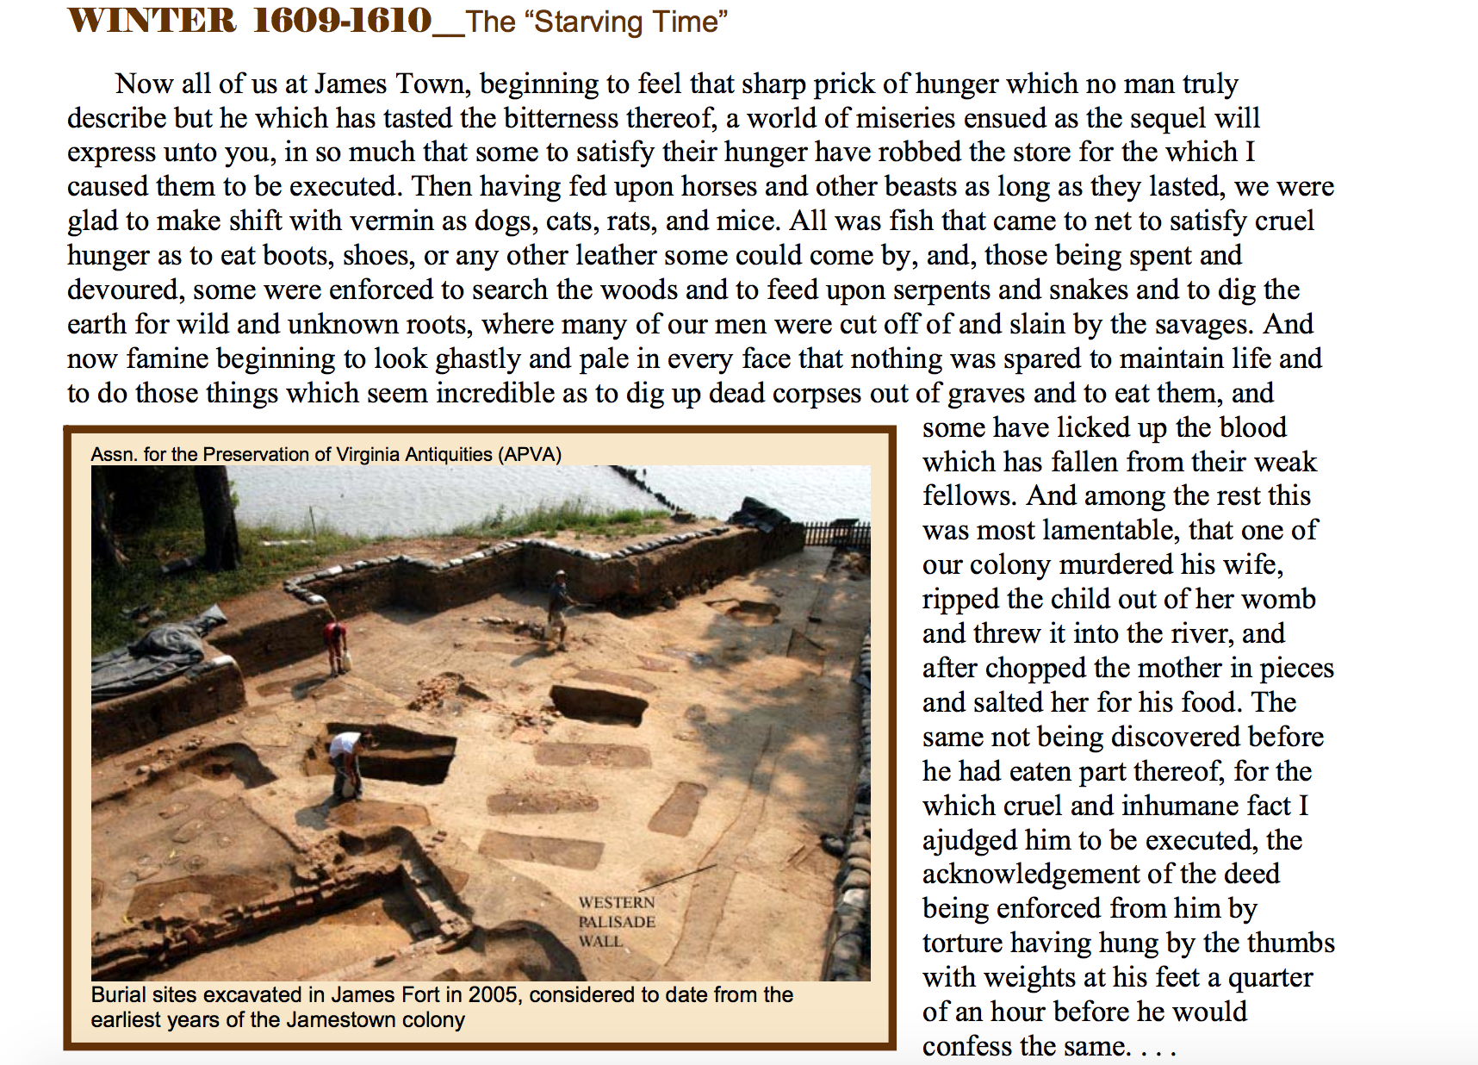

Jot Space:
Put it all together! Remember our big picture question: What was the colonial experience for settlers of Jamestown?
Write a mini-DBQ that explains answers the question above. You must use information from at least 3 sources. You may choose to focus on just one aspect of life, or to give an overall picture of life in the colony. ______________________________________________________________________________________________________________________
______________________________________________________________________________________________________________________
______________________________________________________________________________________________________________________
______________________________________________________________________________________________________________________
______________________________________________________________________________________________________________________
______________________________________________________________________________________________________________________
______________________________________________________________________________________________________________________
______________________________________________________________________________________________________________________
______________________________________________________________________________________________________________________
______________________________________________________________________________________________________________________
______________________________________________________________________________________________________________________
______________________________________________________________________________________________________________________
______________________________________________________________________________________________________________________
______________________________________________________________________________________________________________________
______________________________________________________________________________________________________________________
______________________________________________________________________________________________________________________
______________________________________________________________________________________________________________________
______________________________________________________________________________________________________________________
______________________________________________________________________________________________________________________
______________________________________________________________________________________________________________________
______________________________________________________________________________________________________________________
______________________________________________________________________________________________________________________
______________________________________________________________________________________________________________________
______________________________________________________________________________________________________________________
______________________________________________________________________________________________________________________
______________________________________________________________________________________________________________________
______________________________________________________________________________________________________________________
______________________________________________________________________________________________________________________
______________________________________________________________________________________________________________________
______________________________________________________________________________________________________________________
______________________________________________________________________________________________________________________
______________________________________________________________________________________________________________________
______________________________________________________________________________________________________________________
______________________________________________________________________________________________________________________
______________________________________________________________________________________________________________________
______________________________________________________________________________________________________________________
______________________________________________________________________________________________________________________
______________________________________________________________________________________________________________________
______________________________________________________________________________________________________________________

