Japanese-American internment describes the period from February 1942 until late 1945, when the Roosevelt administration removed over 100,000 Japanese-Americans from their homes and relocated them to camps in the United States. The direct cause of internment was the Japanese sneak attack on Pearl Harbor, on December 7, 1941. The Japanese-American population was high on the West Coast, and many Americans in that region began to get nervous about the threat of spies and saboteurs. There were many rumors that Japanese-American farmers were planting their crops in a way that pointed to military bases or that they were trying to send radio messages to the Japanese. Ultimately, nothing was ever proved. In response to this paranoia, President Roosevelt signed Executive Order 9066 in February of 1942. This gave military commanders jurisdiction to create military zones and exclude potential threats, namely Japanese Americans. By mid-1942, over 100,000 were forcibly removed from their homes and transported to internment camps, where many of them spent the war. After two Supreme Court rulings (Korematsu vs. US and Ex parte Endo) in December 1944, the exclusion order was rescinded, and camps closed later that year. Although internment was over, the effects lingered and are still felt today.
Was internment the right choice?
Internment was a harsh and unnecessary response by the United States government. In fact, even the United States government, who was responsible for this policy, knew it did not work.
In this letter, the Secretary of the Interior describes how the camps are having an unintended effect. Although they are removing potential enemies from mainstream society, many of these Japanese-Americans are becoming “a hostile group.” Instead of solving a problem, the camps created one. Japanese-Americans who had previously been loyal were no longer happy with the United States. It was an extremely hurtful decision with far-reaching implications.

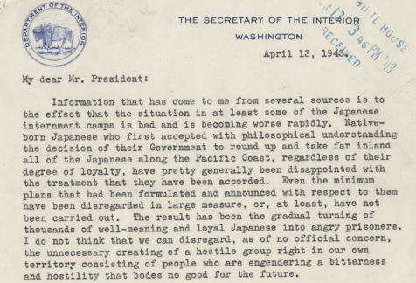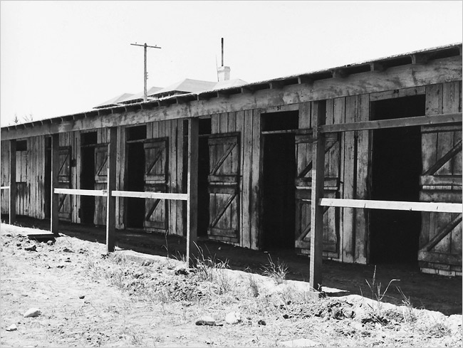
Although the act of interning Japanese-Americans was offensive enough, the conditions were also terrible. This photo may look unremarkable because it is a photo of horse stalls. However, these became the homes of families at Tanforan, one of the camps. Families lived in cramped conditions, without running water or bathrooms in their “homes.” At a basic level, internment was degrading and cruel. Internment was not the right decision. The living standards were so humiliating and they angered Japanese-Americans so much, that the government even realized it was not the right choice.

