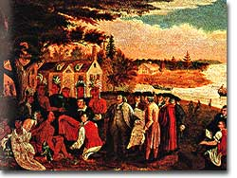
Americans have often prided themselves on their rich diversity. Nowhere was that diversity more evident in than in the middle colonies of Pennsylvania, New York, New Jersey, and Delaware.

Many different groups came to settle in the Middle Colonies. Several groups that came were the English, Swedes, Dutch, Germans, Scots-Irish and French all settled in the Middle Colonies to seek economic gain. Because of the mixing of all these groups in the Middle Colonies, there was not one dominate religion. Instead, there were several religions that were practiced. Quakers, Jews, Lutherans, and Presbyterians all were drawn to Middle Colonies. The area became known for its religious tolerance which only helped attract a diverse group of settlers.
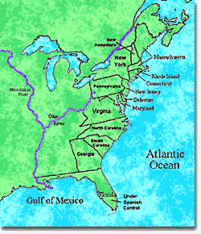
The location of the colonies served as a middle group for the colonies to the North and South. They became a trading hub and the cities of New York and Philadelphia grew quickly. These cities allowed for the development of great craftsmen like welders, shipbuilders, blacksmiths, and wigmakers.
The middle colonies had warm summers and cold winters. Their central location on the Atlantic Coast provided farmable land and allowed for agriculture to develop and support the economy. These colonies made money mostly from farming and trade but there was also a small shipbuilding and lumber business.
The middle colonies represented exactly that — a middle ground between its neighbors to the North and South.

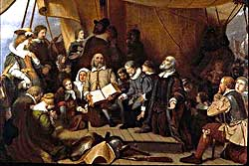
The people who founded New England had a unique goal. Though they cared about gaining prosperity and wealth, their goal was mainly religious. The Europeans who founded the New England colonies were Pilgrims and Puritans. They were seeking freedom from the religious conflict that was occurring in Europe. The New England settlers were Protestants- a group that had broken away from the Catholic Church.
The New England Colonies were Massachusetts, New Hampshire, Connecticut, Maine, and Rhode Island.
New England Colonies were located along the coast line in the North East. The land had dense forests and rocky soil- thus farming was not a main source of money. The colonies also had very cold brutal winters. Most colonies made their living from fishing, whaling, logging, and ship building. Trade was also a major part of the economy.
New England grew as trading towns and the cities along the coast grew as well. Life in these cites was very different from the "city life" that we know today. The streets were narrow dusty roads. Pigs and cows wandered through the streets. And candles were used to light their houses.

A unique characteristic of the New England Colonies was their culture. Unlike the Middle Colonies that were very diverse, the New England colonies were unified. The Puritans were a main social and religious group. Their goal was to “Purify” religion. They had very strict rules and did not accept other religions. Life was dominated by going to church, those who failed to attend or spoke out against the church faced punishment.

The Southern colonies were located along the Atlantic Coastline. Their southern geography led to very fertile/farmable land and a long growing season which made farming easy and profitable.
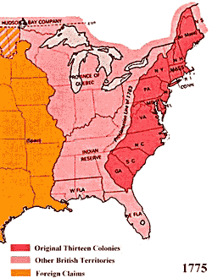
The Southern colonies included Virginia, North and South Carolina, and Georgia.
The Southern Colonies enjoyed warm climate with hot summers and mild winters. The soil was perfect for farming and the growing season was longer than in any other region. Hot summers, however, led to diseases such as malaria and yellow fever.
The Southern colonies grew mainly Cash Crops. A cash crop is grown for a profit and not necessary to eat, such as cotton or tobacco. These crops required a lot of man power to harvest and produce. Because of this, the economy of the south turned to slave labor
Slaves and indentured servants, although present in the North, were much more important to the South. They were the backbone of the Southern economy. The large plantations required large man power to operate. From early on, the slavery system developed and grew in the South.
Settlers in the Southern colonies came to America to seek wealth they could not find in Old England. America provided more space to realize a lifestyle the new arrivals could never dream to achieve in their native land. Thus, many families came over to try their hand at a tobacco plantation and strike it rich.
The colonial South had more religious diversity than Puritan New England. Some of the first founding families established Anglican churches but as time progressed, Baptist and Methodist churches grew popular.
One of main features of the South was the plantation. A plantation is a large plot of land that contained a great many acres of farmland and buildings in which lived the people who owned the land and the people who worked the land. The South had fewer big cities than the colonies to the North and developed a more rural lifestyle.

