Name: ______________________________ Date: ________________ Period: _________
Introducing the Quote Sandwich!
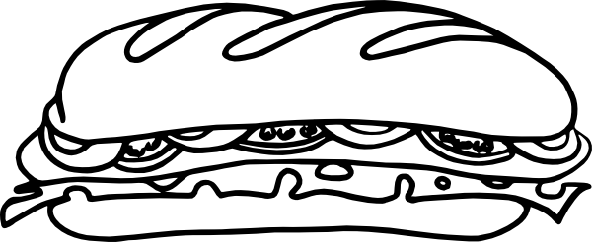
As you are mastering the PEE method of writing, it’s time to step up your writing game! Evidence is the key to writing a well-supported paragraph. You have become masters of using quotes- but now it’s time to talk about how to use quotes well in your paragraphs.
Quotes hate to be on islands. They would much rather be in a sandwich!
Here’s what that means: When using a quote, you always need to introduce the quote and explain it.

Don’t leave a quote stranded on an island. Make it a part of a lovely, delicious quote sandwich!
Look at the two examples below:
Example 1: Many examples of Aztec technology have been found in their city. “Tenochtitlan had many large scale pyramids and temples that were used for ceremonies and sacrifices” (Doc 4). There were also examples of technology in their farming methods.
Example 2: Many examples of Aztec technology have been found in their city. One historian, David Smith, noted several specific examples by stating, ““Tenochtitlan had many large scale pyramids and temples that were used for ceremonies and sacrifices” (Doc 4). This illustrates the Aztecs had the technology to build on a large scale and create impressive structures even without today’s modern technology.
- See the difference? Which example is better? Explain why?

Example one is stranded on an island. Example two is all comfy and sandwiched in. You can understand the meaning of the second example much better.
Here’s how to do it on your own:
Step One: Introduce your quote with context. You can use introductory statements like:
One example is seen when, (insert author’s name) states … The author, (Insert name) shows…
In Document Four, a secondary source, it stated that … An article titled (insert name) suggests…
Document Three, a primary source by (insert name) says…
In (article/text title), the author states…
Step Two: Use your quote- you only need to use the parts of the quote that support your idea- this is included in the same sentence as your introduction.
Step Three: Analyze the quote and explain what it means. You can use analysis statements like:
This shows that… It is clear that… This demonstrates…
This illustrates… This statement exemplifies that… The quote proves…
The author suggests in this statement… The author’s point of view is…
Let’s Practice!
Now try pulling out your own evidence. Read the short passage below then follow the instructions below the article to practice your quote sandwiches.
Aztec Inventions
Secondary Source: Taken from an article Titled “Aztec Inventions” by John Calhoun on Encyclopedia Britannica
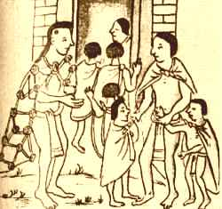
Are there any Aztec inventions that are still in use in the world today? It's actually a tricky question, and it depends on what you mean by "invention". Read the passage below to find out the unique things the Aztecs used that we still use today.
Education for All
You might not think of this when you think about Aztec inventions, but the empire was one of the first places in the world to have mandatory education for everyone. In the years ahead, education was going to become more and more important around the world - but the peoples of the Aztec empire were on the cutting edge. Many countries had education for the upper classes, but for the Aztec education was important no matter what your gender, rank or station.
Popcorn
This "Aztec invention" really came along long before the time of the Aztecs. However, it was the Aztecs that introduced it to the rest of the world. But when the Spanish arrived, Hernan Cortes saw popcorn for the first time. It was used as an accessory and decoration on headdresses, and to decorate the god of maize and fertility.
Gum
The Mayans, for one, discovered that they could take the thick milky liquid from a tree harden it into gum. The liquid was "chicle", a word you can still hear on street corners in Mexico from vendors selling chewing gum. You could find Aztec children chewing gum on the street corners and selling it to earn money.
______________________________________________________________________________________________
Instructions: Now find two quotes that prove that the Aztecs had inventions that we still use today. Use those quotes in a quote sandwich to show that you have mastered this new idea. Look back to the previous page for sentence starters. Since the passage has no author or document number you can refer to it just as an article.
- First Identify your source: Who is the author? ___________________________________________
What is the name of the article this text comes from? ______________________________________________
- Quote 1 Sandwich:
________________________________________________________________________________________________________________________________________________________________________________________________________________________________________________________________________________________________________________________________________________________________________________________________________________________________________________________________________________________________________________________________________________________________________________________________________________________________________________________________________________________________________________________________________________________________________________________________________________
Check- did you do all 3 steps?

- Quote 2 Sandwich:
____________________________________________________________________________________________________________________________________________________________________________________________________________________________________________________________________________________________________________________________________________________________________________________________________________________________________________________________________________________________________________________________________________________________________________________________________________________________________________________________________________________________________________________________________________________________________________________________________________________________________________________________________________________________________________________________________________________________________________________________________________________

If you have time and are waiting for other students to finish- find a third quote
____________________________________________________________________________________________________________________________________________________________________________________________________________________________________________________________________________________________________________________________________________________________________________________________________________________________________________________________________________________________________________________________________________________________________________________________________________________________________________________________________________________________________________________________________________________________________________________________________________________________________________________________________________________________________________________________________________________________________________________________________________________

