The New Tycoons: John D. Rockefeller

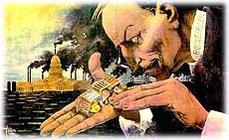
John D. Rockefeller (1839-1937) He was America's first billionaire.
In a pure sense, the goal of any capitalist is to make money. And John D. Rockefeller could serve as the poster child for capitalism. Overcoming humble beginnings, Rockefeller had the vision and the drive to become the richest person in America.
At the turn of the century, when the average worker earned $8 to $10 per week, Rockefeller was worth millions.

Robber Baron or Captain of Industry?
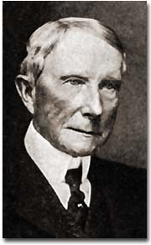
What was his secret? Is he to be placed on a pedestal for others as a "captain of industry?" Or should he be demonized as a "robber baron." A robber baron, by definition, was an American capitalist at the turn of the 19th century who enriched himself upon the sweat of others, exploited natural resources, or possessed unfair government influence.
Whatever conclusions can be drawn, Rockefeller's impact on the American economy demands recognition.
Rockefeller was born in 1839 in Moravia, a small town in western New York. His father practiced herbal medicine, professing to cure patients with remedies he had created from plants in the area. John's mother instilled a devout Baptist faith in the boy, a belief system he took to his grave. After being graduated from high school in 1855, the family sent him to a Cleveland business school.
Young John Rockefeller entered the workforce on the bottom rung of the ladder as a clerk in a Cleveland shipping firm. Always thrifty, he saved enough money to start his own business in produce sales. When the Civil War came, the demand for his goods increased dramatically, and Rockefeller found himself amassing a small fortune.
He took advantage of the loophole in the Union draft law by purchasing a substitute to avoid military service. When Edwin Drake discovered oil in 1859 in Titusville, Pennsylvania, Rockefeller saw the future. He slowly sold off his other interests and became convinced that refining oil would bring him great wealth.

Waste Not...
Rockefeller introduced techniques that totally reshaped the oil industry. In the mid-19th century, the chief demand was for kerosene. In the refining process, there are many by-products when crude oil is converted to kerosene. What others saw as waste, Rockefeller saw as gold. He sold one byproduct paraffin to candlemakers and another byproduct petroleum jelly to medical supply companies. He even sold off other "waste" as paving materials for roads. He shipped so many goods that railroad companies drooled over the prospect of getting his business.
Rockefeller demanded rebates, or discounted rates, from the railroads. He used all these methods to reduce the price of oil to his consumers. His profits soared and his competitors were crushed one by one. Rockefeller forced smaller companies to surrender their stock to his control.

Standard Oil — a Trust-worthy Company?
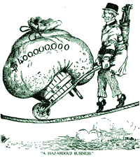
This sort of arrangement is called a trust. A trust is a combination of firms formed by legal agreement. Trusts often reduce fair business competition. As a result of Rockefeller's shrewd business practices, his large corporation, the Standard Oil Company, became the largest business in the land.
As the new century dawned, Rockefeller's investments mushroomed. With the advent of the automobile, gasoline replaced kerosene as the number one petroleum product. Rockefeller was a bona fide billionaire. Critics charged that his labor practices were unfair. Employees pointed out that he could have paid his workers a fairer wage and settled for being a half-billionaire.
Before his death in 1937, Rockefeller gave away nearly half of his fortune. Churches, medical foundations, universities, and centers for the arts received hefty sums of oil money. Whether he was driven by good will, conscience, or his devout faith in God is unknown. Regardless, he became a hero to many enterprising Americans.

The New Tycoons: Andrew Carnegie
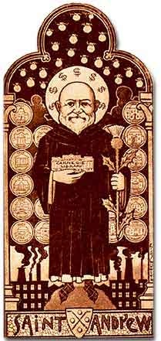
Oil was not the only commodity in great demand during the Gilded Age. The nation also needed steel.
The railroads needed steel for their rails and cars, the navy needed steel for its new naval fleet, and cities needed steel to build skyscrapers. Every factory in America needed steel for their physical plant and machinery. Andrew Carnegie saw this demand and seized the moment.

Humble Roots
Andrew Carnegie was not born into wealth. When he was 13, his family came to the United States from Scotland and settled in Allegheny, Pennsylvania, a small town near Pittsburgh. His first job was in a cotton mill, where he earned $1.20 per week.
His talents were soon recognized and Carnegie found himself promoted to the bookkeeping side of the business. An avid reader, Carnegie spent his Saturdays in the homes of wealthy citizens who were gracious enough to allow him access to their private libraries. After becoming a telegrapher for a short while, he met the head of a railroad company who asked his services as a personal secretary.

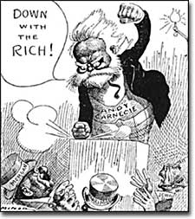
During the Civil War, this man, Thomas Scott, was sent to Washington to operate transportation for the Union Army. Carnegie spent his war days helping the soldiers get where they needed to be and by helping the wounded get to hospitals. By this time, he had amassed a small sum of money, which he quickly invested. Soon iron and steel caught his attention, and he was on his way to creating the largest steel company in the world.

Vertical Integration: Moving on Up
Carnegie became a tycoon because of shrewd business tactics. Rockefeller often bought other oil companies to eliminate competition. This is a process known as horizontal integration. Carnegie also created a vertical combination, an idea first implemented by Gustavus Swift. He bought railroad companies and iron mines. If he owned the rails and the mines, he could reduce his costs and produce cheaper steel.
Carnegie was a good judge of talent. His assistant, Henry Clay Frick, helped manage the Carnegie Steel Company on its way to success. Carnegie also wanted productive workers. He wanted them to feel that they had a vested interest in company prosperity so he initiated a profit-sharing plan.
All these tactics made the Carnegie Steel Company a multi-million dollar corporation. In 1901, he sold his interests to J.P. Morgan, who paid him 500 million dollars to create U.S. Steel.

Giving Back
Retirement did not take him out of the public sphere. Before his death he donated more than $350 million dollars to public foundations. Remembering the difficulty of finding suitable books as a youth, he helped build three thousand libraries. He built schools such as Carnegie-Mellon University and gave his money for artistic pursuits such as Carnegie Hall in New York.
Andrew Carnegie was also dedicated to peace initiatives throughout the world because of his passionate hatred for war. Like Rockefeller, critics labeled him a robber baron who could have used his vast fortunes to increase the wages of his employees. Carnegie believed that such spending was wasteful and temporary, but foundations would last forever. Regardless, he helped build an empire that led the United States to world power status.
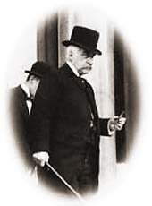

The New Tycoons: J. Pierpont Morgan
Child of Privilege
Not all of the tycoons of the Gilded Age were rags-to-riches stories. J. Pierpont Morgan was born into a family of great wealth. His father had already made a name for himself in the banking industry. With Morgan's family resources, he enjoyed the finest business education money could buy.
He did not scratch and claw his way to the top of any corporate ladder. His father arranged for an executive track position at one of New York's finest banks. Regardless of his family's advantages, Morgan had a great mind of his own. He set out to conquer the financial world, and conquer it he did.

Morgan the Banker
Morgan's first business ventures were in banking. By 1860, he had already established his own foreign exchange office. He knew the power of investment. Not content to control just the banking industry, he bought many smaller ventures to make money.
During the Civil War, he paid the legally allowed fee to purchase a substitute soldier and evaded military service. Morgan made handsome profits by providing war materials. One of his enterprises sold defective rifles to the Union army. Upon later investigations, he was declared ignorant of the poor quality of his guns and was cleared of all charges.
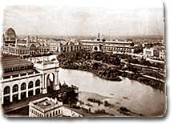
After the war, he set out to corner the nation's financial markets. When the Panic of 1873 rocked the nation's economy, Morgan protected himself wisely and emerged in the aftermath as the king of American finance.
Despite his label as a robber baron, Morgan felt his investments benefited America. His railroad dealings helped consolidate many smaller, mismanaged firms, resulting in shorter trips and more dependable service. Two times during financial panics he allowed the federal government to purchase his vast gold supplies to stop the spiral of deflation.
He owned a bridge company and a tubing company. His most renowned purchase was in 1901, when he bought the Carnegie Steel Company for $500 million to create U.S. Steel. Within ten years U.S. Steel was worth over a billion dollars.
Morgan's actions marked a shift in thinking among American industrialists. He proved that it was not necessary to be a builder to be successful. Smart investment and efficient consolidation could yield massive profits. Young entrepreneurs shifted their goals to banking in the hopes of mirroring Morgan's success.

Trouble with the Government

For all his accomplishments, he was harshly criticized. The first decade of the twentieth century brought challenges to Morgan from the government. His Northern Securities railroad company was deemed illegal under federal antitrust law, the first such action by the national government. He was investigated by Congress for his control of the financial markets. Even U.S. Steel was forced to relinquish its monopoly.
Jaded by the criticism, Morgan moved to Europe, where he lived his final days. He was a favorite target of intellectuals who claimed that such tycoons robbed the poor of their deserved wealth. He was a hero to enterprising financiers across the land who dreamed of following his example. That is, of course, unless they were destroyed by his shrewd, fierce tactics.

