Unit 1 Foundations of America- Review Sheet
This examination tests the mastery of Standard: 11.1 Students analyze the significant events in the founding of the nation and its attempts to realize the philosophy of government described in the Declaration of Independence
Key Terms- Know the definitions and importance of the following terms
1. Patriot-
2. Loyalist-
3. Columbian Exchange-
4. Tyranny-
5. Cash Crop-
6. Colony-
7. Grievance-

13 Colonies Map- Be able to label all of the 13 Colonies
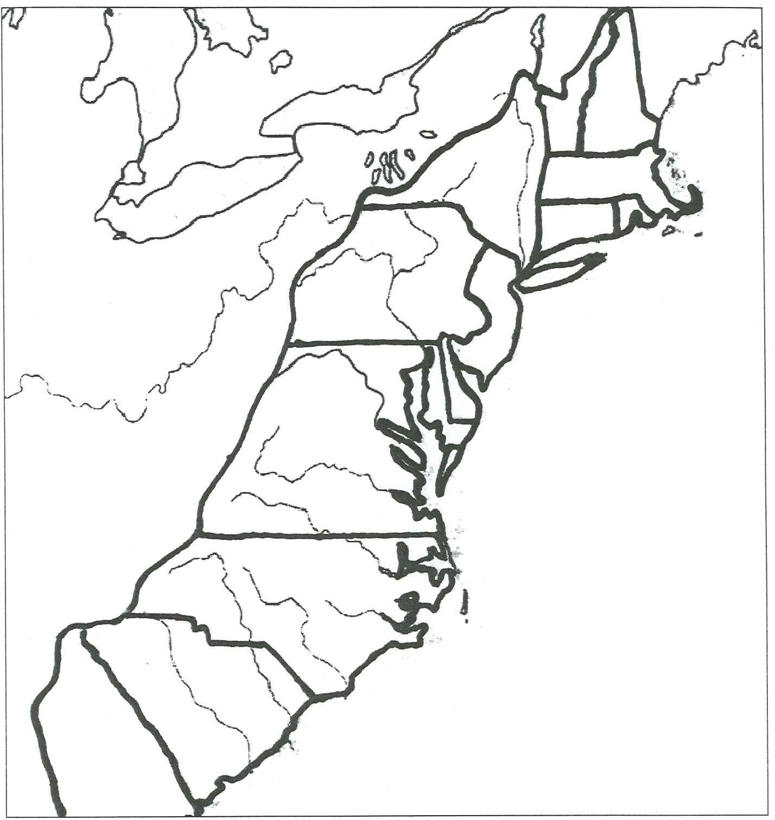
11. Shade the New England, Middle, and Southern Colonies

Colonial Taxes- Know what each act taxed and its result
12. Quartering Act-

13. Stamp Act-

14. Townshend Acts-

15. Intolerable Acts-

16. Tea Act-

17. Early Settlers of the Americas- Complete the Chart and know each group
 | Location | Economy | Relationship with Natives
French
English
Spanish

18. List 3 characteristics of the Middle Colonies
A. Religion-
B. Location-
C. Economy-
19. List 3 characteristics of the Southern Colonies
A. Economy-
B. Reason for Settlement-
C. Location-
20. List 3 characteristics of the New England Colonies
A. Reason for settlement-
B. Religion-
C. Economy-
21. Know one positive and one negative outcome of the French and Indian War
Positive:

Negative:

22. Know 3 Weaknesses of the Articles of Confederation
A.
B.
C.

23. Know the difference between the Virginia Plan and New Jersey Plan

24. Fill in the chart below about Christopher Columbus
Positives of Columbus’s Interaction with Natives | Negatives of Columbus’s Interaction with Natives
A.  B.  C. | A.  B.  C.

25. List 3 hardships for colonists in Jamestown

26. Know the events that led up to the Revolutionary War

27. Which country became a US ally during the Revolutionary War?

28. Declaration of Independence- What was the purpose of this document? What rights did the colonists declare they had?

