Name______________________________________________ Date_______________ Period_____
September 11th Mini DBQ
Historic Context: On September 11th, 2001, 19 radical Muslims took over four airplanes and carried out terrorist attacks against the United States. Two planes were flown into the towers of the World Trade Center in New York City, a third plane hit the Pentagon just outside Washington, DC, and the fourth plane crashed in a field in Pennsylvania. Often referred to as 9/11, the attacks resulted in the death of over 3,000 people in New York City and Washington DC. After the attacks, American citizens were terrified and shocked and looked for someone to blame for the terrible events. Many looked towards the Muslim citizens in the country.

Task: Discuss the treatment of Muslim Americans after 9/11 and how Muslim lives’ changed after 9/11.

Part A: The documents below relate information about Muslims in the United States after the September 11th attacks. Examine each document carefully, and then answer the questions that follow it. These answers will help you in part B.
Document 1
The week after 9/11 was awful. Everything was shut down for days — transportation, schools, stores. My family and I stayed in the house the entire week. My father was afraid to let us out because of the violence against Muslims. We heard horror stories about Muslims who were beaten and women who had their scarves ripped off their heads. Some were even raped.
I was so angry. I was furious that these men, who claimed to be Muslim, would do such a thing. Who would kill thousands of innocent people? Don’t they know that these acts of violence would affect all of us? I wanted to get in front of a camera and explain to everyone, “We’re not all the same. We condemn this violence. This is not what our religion teaches us. We’re supposed to be peaceful. The Koran tells us that killing one person is like killing all of humanity.”
-Zahra Huber, a reporter, editor, and producer at CBS News in Detroit
- Why didn’t Ms. Huber’s father want the family to go outside?___________________________________________
_____________________________________________________________________________________________________________________________________________________________________________________________________________________________________________________________________________________________
- According to Ms. Huber, do all Muslims believe in committing terrorist attacks? Why or why not?
_____________________________________________________________________________________________________________________________________________________________________________________________________________________________________________________________________________________________

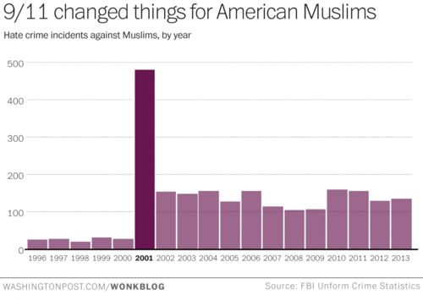
Document 2
After September 11th, 2001, Muslims faced a drastic increase in hate crimes. A hate crime is a crime motivated by racial, sexual, or other prejudice, typically one involving violence. Although the September 11th attacks were carried out by a few radical Muslims, many Americans blamed all Muslims, and targeted American Muslims in their communities.

- What does the graph show increased in 2001? _____________________________________________________
- How many more hate occurred in 2001 than in 2000? Answers can be estimated. _________________________
Document 3
Many Muslim travelers say that since the Sept. 11 terrorist attacks they have been singled out for questioning by the police and security workers at American airports. Muslim women have been told to remove their headscarves at airport security checkpoints, which is a violation of their beliefs.
The American-Arab Anti-Discrimination Committee has received reports from 21 Arab and Muslim travelers who were evicted from their flights after pilots or flight attendants refused to travel with them because of the way they look or because they had Arabic-sounding names.
''This is outright discrimination and prejudice,” said one Muslim airline passenger. “It's making decisions on how people look and what their names sound like. This didn’t happen before, and shouldn’t be happening in America.''
-Laurie Goodstein, New York Times, November 11, 2001.
- What happened to Muslims in airports after the September 11th attacks? ____________________________
______________________________________________________________________________________________________________________________________________________________________________________________________________________________________________________

- How did this change the lives of Muslims?___________________________________________________ ____________________________________________________________________________________________________________________________________________________________________
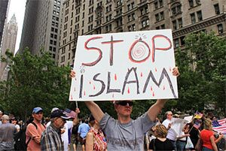
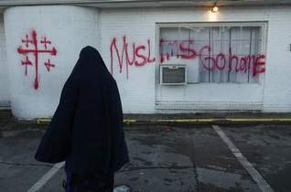
Document 4

- What do the images show about American reactions towards Muslims after 9/11?
_______________________________________________________________________________________________________________________________________________________________________________________________________________________________________________________________
Part B: Mini Essay Task: Using the documents above, your answers to the questions in Part A and your knowledge of social studies, write a well-developed paragraph that explains how Muslims were treated and how their lives changed after 9/11. (USE PEE and USE 3 Pieces of Evidence!)
________________________________________________________________________________________________________________________________________________________________________________________________________________________________________________________________________________________________________________________________________________________________________________________________________________________________________________________________________________________________________________________________________________________________________________________________________________________________________________________________________________________________________________________________________________________________________________________________________________________________________________________________________________________________________________________________________________________________________________________________________________________________________________________________________________________________________________________________________________________________________________________________________________________________________________________________________________________________________________________________________________________________________________________________________________________________________________________________________________________________________________________________________________________________________________________________________________________________________________

