Name: ____________________________
Aztec DBQ- What should history say about the Aztecs?
Document Packet
First let’s review the steps in writing a DBQ essay:
- Read the background information- for this DBQ the background comes in the form of a background essay. This essay is very important to you understanding the context for your DBQ. Read it carefully and answer the comprehension questions that follow it.
- Carefully read the task. Consider what you already know about the topic and make sure you understand what the task is asking you to know.
- Read each document carefully. Underline key phrases and words.
- Answer the questions that follow each document. These questions are there to help you break down and analyze important information about your document.
- Create a thesis that answers the task question.
- Write a well-organized essay about your thesis. Your essay should include support from the documents!
Background: Throughout history, much has been recorded about the Aztecs. Some historians are amazed at their massive city and impressive social structure while others are appalled by the violence and sheer number of human sacrifices. Now it’s your turn!
TASK: Using the documents provided as your support, you will decide what side of Aztec history should be told. Will it be a positive or negative outlook of the Aztecs? That will depend on your point of view and the documents you choose to use.
Due Dates:
Part 1: Document Analysis- Read each document and answer the corresponding questions. Complete Coding Chart Due: ____________
Part 2: Rough Draft- Complete rough draft template included in this paragraph Due: __________
Part 3: Have paper proofread- one adult needs to complete the proofreading sheet you will receive. This will count as a homework grade Due: ___________
Part 4: Final Typed Paper Due: ___________
Final Product: Your final product for this DBQ will be a typed, 12 pt font, double spaced, 5 paragraph essay. Your essay needs to include at least 3 documents to support your thesis.

Part A: Analysis of Documents. Read each document carefully and answer the questions that follow to help you break down each document
Document 1:
Long Document

Document 2: Aztec Flower Wars
Document 5: Primary Source of a Sacrific Ritual
Author: A seventeen year old Aztec Scribe records his impressions of a Sacrifice Ritual which is recorded and told to Friar Bernardino de Sahagun several years later in 1529)

“When I saw this ceremony last year as a member of the priestly school, I was amazed by the physical beauty of the enemy warrior was killed at the end of the festival. This seasoned warrior, whom we change from a human into the god Tezcatlipoca, can have no blemish upon his body, and he is treated like our most royal family member during the long year leading up to his sacrifice. During that time he is given all the finest luxuries from the noble’s storehouses, including foods, clothes, teachers, women, and instruction…
Many of us become attached to this living god, and a terrible sadness comes over some of the women when, at the end of the year, he is taken to Chalco and dismembered in public view.”
- Who is the author and what is his purpose in writing about this sacrifice?

- What do we learn from the account?

- If a historian’s only evidence on Aztec sacrifice was Document 5, what might that historian say about the subject?

Document : Chinampas Agriculture
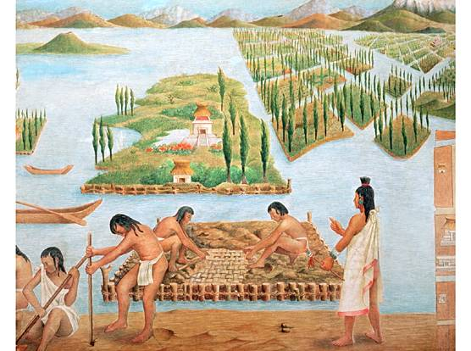
Source: "Chinampa". Encyclopædia Britannica. Encyclopædia Britannica Online.
Encyclopædia Britannica Inc., 2015. Web. 03 Nov. 2015
Chinampas, also called floating gardens, are small, stationary, artificial islands built on a freshwater lake for agricultural purposes. Typically they were made up building up a number of narrow islands, each averaging some 20 to 35 feet wide and some 325 to 650 feet long, using layers of vegetation, dirt, and mud. The lake provides the chinampa with a water source that moistens and fertilizes the island’s soil, supporting a highly productive form of agriculture.

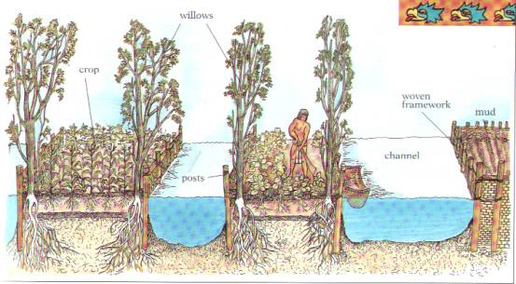
- Using the text, summarize how chinampas are made.
- What inferences can you make about the level of organization in the Aztec economy?

Document : The City of Tenochtitlan
Image Source: Models created to represent the historical layout of the city of Tenochtitlan
Tenochtitlan was a capital city built on a landfill (the earth had been dragged from surrounding swamp or brought by canoe from the mainland). There were two earthenware channels and one masonry aqueduct (a channel for carrying water) that carried fresh drinking water the three miles from the mainland to Tenochtitlan. It is believed that Tenochtitlan had one of the best fresh water delivery systems in the world at the time. The city supported a population of up to 300,000 people at one point and had a highly organized layout.

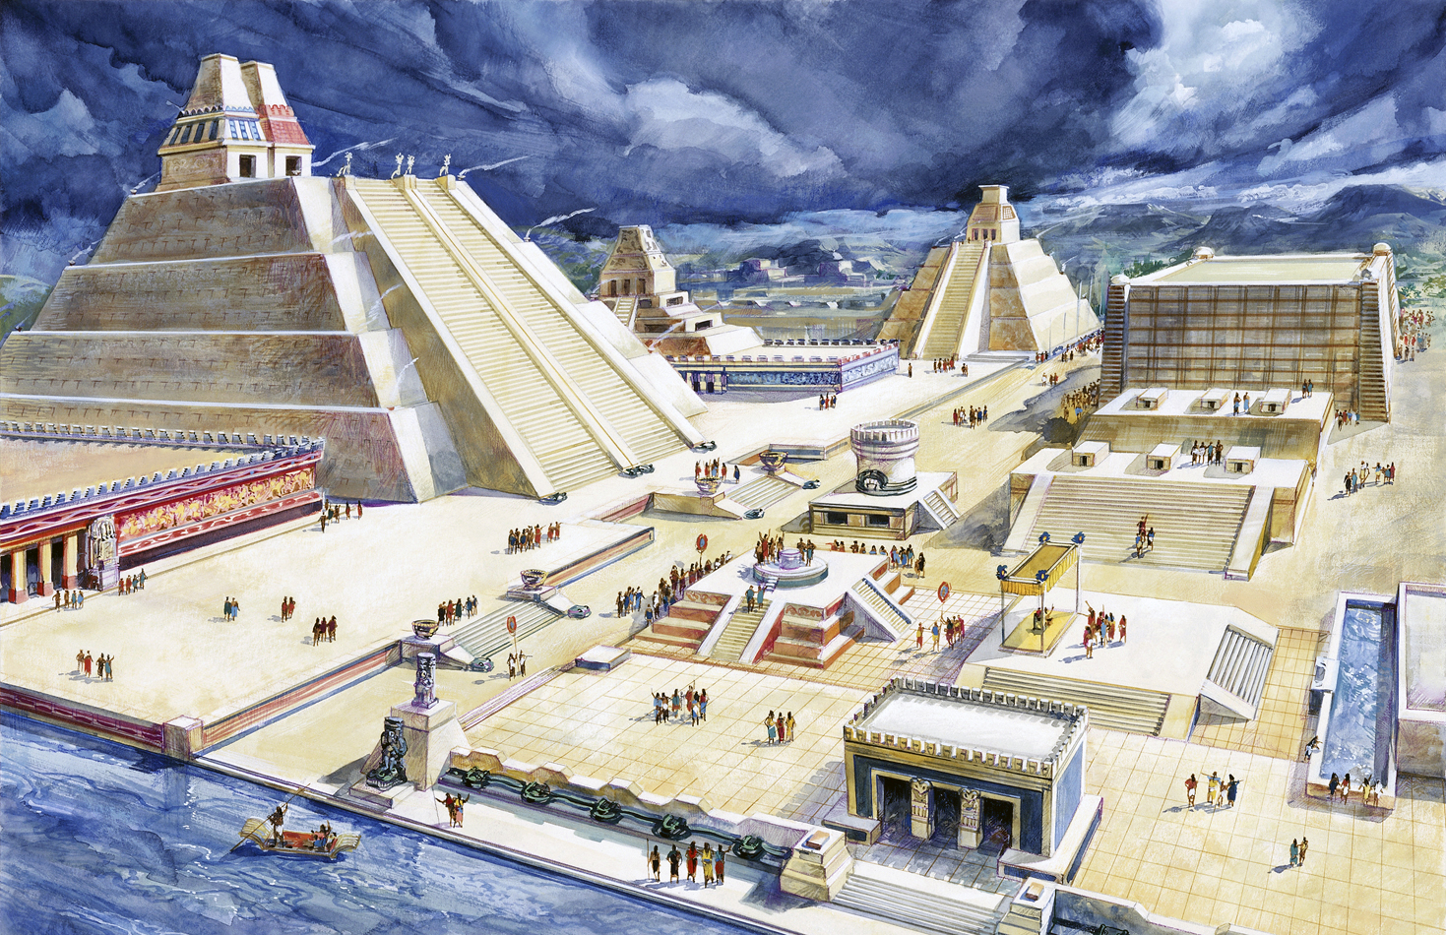
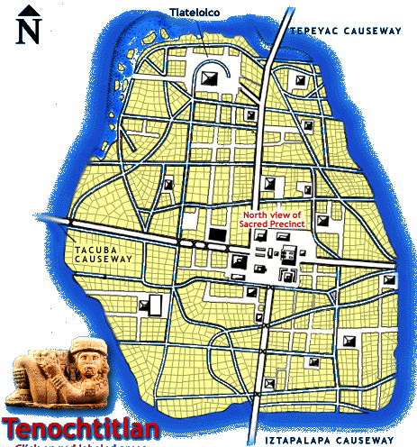

- Examine the images, what evidence of advanced architecture and social organization do you see? Try to least at least 4 things.
- If you had to write a paragraph about Aztec architecture and organization, what would your topic sentence be? What would be one piece of evidence to support that

Document 1: Growth of the Aztec Empire (map)
- Does the map support or deny that fact that the Aztecs had an impressive and successful military? How does the map show this?
________________________________________________________________________________________________________________________________________________________________________
____________________________________________________________________________________
____________________________________________________________________________________

- Why did the Aztecs conquer so much land? What were they in need of?
________________________________________________________________________________________________________________________________________________________________________
____________________________________________________________________________________
Document 2: Justification for Aztec Reign Over Central Mexico (drawing)
- What reasons did the Aztecs believe they needed to settle at Tenochitilan?
________________________________________________________________________________________________________________________________________________________________________
____________________________________________________________________________________
____________________________________________________________________________________
____________________________________________________________________________________

Document 3: Itzcoatl and Tlacael Adjust Aztec History
Please dismiss this document- you do not need to include it in your DBQ

Document 4: Tenochtitlan (two images)
- How does the caption say that Tenochtitlan compare to other cities of its time(London)?
________________________________________________________________________________________________________________________________________________________________________
____________________________________________________________________________________
___________________________________________________________________________________
___________________________________________________________________________________

- What is impressive about the features shown in the images- include at least 3 things you notice about the images?
_______________________________________________________________________________________________________________________________________________________________________
____________________________________________________________________________________
____________________________________________________________________________________
___________________________________________________________________________________

Document 5: A Young Scribe's Impressions of Ritual Sacrifice
- Discuss two ways the Aztec prisoner treated before his death?
_______________________________________________________________________________________________________________________________________________________________________
____________________________________________________________________________________
____________________________________________________________________________________

- What is the response of the people when the prisoner is killed?
________________________________________________________________________________________________________________________________________________________________________
____________________________________________________________________________________
____________________________________________________________________________________

Document 6: The Scale of Sacrifice (drawing)
- What does the image show-list at least 3 descriptors?
________________________________________________________________________________________________________________________________________________________________________
____________________________________________________________________________________
____________________________________________________________________________________
____________________________________________________________________________________

- Briefly describe the process of human sacrifice.
________________________________________________________________________________________________________________________________________________________________________
____________________________________________________________________________________
___________________________________________________________________________________

Document 7: Understanding Aztec Sacrifice

- What does the phrase “intentional manipulation” refer to in regard to the Aztec practice of human sacrificing?
________________________________________________________________________________________________________________________________________________________________________
____________________________________________________________________________________
___________________________________________________________________________________

- What did Marvin Harris suggest about Aztec human sacrifices?
________________________________________________________________________________________________________________________________________________________________________
____________________________________________________________________________________
___________________________________________________________________________________
Document 8: Chinampas Agriculture (drawings)

- What did Chinampas allow the Aztecs to do?
________________________________________________________________________________________________________________________________________________________________________
____________________________________________________________________________________
__________________________________________________________________________________

- Describe the structure of Chinampas- how are they laid out?
________________________________________________________________________________________________________________________________________________________________________
____________________________________________________________________________________
___________________________________________________________________________________
Document 9: Diego Rivera Mural

- Why would someone be dressed as a “corn goddess” in the picture?
________________________________________________________________________________________________________________________________________________________________________
____________________________________________________________________________________
___________________________________________________________________________________

- What does this picture tell you about the importance of religion in Aztec farming practices?
________________________________________________________________________________________________________________________________________________________________________
____________________________________________________________________________________

Document 10: Tribute Demands: (drawing)

- List at least 6 goods that the Aztecs demanded tribute to them from conquered territories.
________________________________________________________________________________________________________________________________________________________________________
____________________________________________________________________________________
___________________________________________________________________________________

- Does this Document make the Aztecs seem strong ? Or too powerful? Explain your answer
________________________________________________________________________________________________________________________________________________________________________
____________________________________________________________________________________
___________________________________________________________________________________

Document 11: The Market of Tenochtitlan

17. Give 3 descriptors of what the Aztec market place must have looked like.
________________________________________________________________________________________________________________________________________________________________________
____________________________________________________________________________________
___________________________________________________________________________________

Document 12: Childhood, Marriage, and Discipline
- Explain how Aztec men and women became married.
__________________________________________________________________________________________________________________________________________________________________
_________________________________________________________________________________
_________________________________________________________________________________
- How would you describe the Aztec social structure?
__________________________________________________________________________________________________________________________________________________________________
__________________________________________________________________________________________________________________________________________________________________

Part C: Each Document tells either a positive or negative view of Aztec culture. Code each document in the chart below as Positive or Negative and give a quick explanation why the text supports your view.
Document | Positive or Negative | Evidence from text
1
2
4
5
6
7
8
9
10
11
12
Part D: Create your thesis- Based on the chart above, what is your opinion of the Aztecs? Do you believe a positive or negative view of the Aztecs should be told by historians?
Examples:
Positive View Thesis: The Aztecs should be remembered as an advanced civilization because of ________1________, ________2___________, and _______3_________.
Negative View Thesis: The Aztecs should be remembered as a violent and cruel civilization because of _______1________, ___________2__________, and ___________3__________.

Your Thesis: _____________________________________________________________________________
________________________________________________________________________________________
________________________________________________________________________________________
What documents will you use to support your thesis? Write the document numbers in this box for an easy reference point.

Paper Structure- Refer to the diagram
Introduction- Background Info
Thesis
to remember how your paper should
be structured
Body Paragraph 1- About evidence 1 from your thesis

Body Paragraph 2- About evidence 2 from your thesis

Body Paragraph 3- About evidence 3 from your thesis

Conclusion-
Restate Thesis and Summarize main points

Part E: Draft your essay- A strong essay will include the format and information listed below:
Fill in the chart below and use it for background information to include in your introduction paragraph
Who were the Aztecs?
Where did they live?
When? - Time Frame
What are they well known for? List several achievements
Introduction Paragraph:
_________________________________________________________________________________________________
_________________________________________________________________________________________________
_________________________________________________________________________________________________
_________________________________________________________________________________________________
_________________________________________________________________________________________________
_________________________________________________________________________________________________
_________________________________________________________________________________________________
_________________________________________________________________________________________________
_________________________________________________________________________________________________
_________________________________________________________________________________________________
_________________________________________________________________________________________________
_________________________________________________________________________________________________
_________________________________________________________________________________________________
_________________________________________________________________________________________________
_________________________________________________________________________________________________
_________________________________________________________________________________________________
Thesis- Remember to place your thesis as the last sentence of your introduction
Body Paragraph 1- This paragraph should discuss the 1st piece of evidence you listed in your thesis.
Check off all the boxes as you include them in your paragraph to make sure you are including all you need to
Topic Sentence Evidence for a document Quote sandwich Citation

Explanation and Analysis of your evidence
_________________________________________________________________________________________________
_________________________________________________________________________________________________
_________________________________________________________________________________________________
_________________________________________________________________________________________________
_________________________________________________________________________________________________
_________________________________________________________________________________________________
_________________________________________________________________________________________________
_________________________________________________________________________________________________
_________________________________________________________________________________________________
_________________________________________________________________________________________________
_________________________________________________________________________________________________
_________________________________________________________________________________________________
_________________________________________________________________________________________________
_________________________________________________________________________________________________
_________________________________________________________________________________________________
_________________________________________________________________________________________________
_________________________________________________________________________________________________
_________________________________________________________________________________________________
_________________________________________________________________________________________________
_________________________________________________________________________________________________
_________________________________________________________________________________________________
_________________________________________________________________________________________________
_________________________________________________________________________________________________

Body Paragraph 2- This paragraph should discuss the 2nd piece of evidence you listed in your thesis.
Check off all the boxes as you include them in your paragraph to make sure you are including all you need to
Topic Sentence Evidence for a document Quote sandwich Citation

Explanation and Analysis of your evidence

_________________________________________________________________________________________________
_________________________________________________________________________________________________
_________________________________________________________________________________________________
_________________________________________________________________________________________________
_________________________________________________________________________________________________
_________________________________________________________________________________________________
_________________________________________________________________________________________________
_________________________________________________________________________________________________
_________________________________________________________________________________________________
_________________________________________________________________________________________________
_________________________________________________________________________________________________
_________________________________________________________________________________________________
_________________________________________________________________________________________________
_________________________________________________________________________________________________
_________________________________________________________________________________________________
_________________________________________________________________________________________________
_________________________________________________________________________________________________
_________________________________________________________________________________________________
_________________________________________________________________________________________________
_________________________________________________________________________________________________
_________________________________________________________________________________________________
_________________________________________________________________________________________________
_________________________________________________________________________________________________
Body Paragraph 3- This paragraph should discuss the 3rd piece of evidence you listed in your thesis.
Check off all the boxes as you include them in your paragraph to make sure you are including all you need to
Topic Sentence Evidence for a document Quote sandwich Citation

Explanation and Analysis of your evidence
_________________________________________________________________________________________________
_________________________________________________________________________________________________
_________________________________________________________________________________________________
_________________________________________________________________________________________________
_________________________________________________________________________________________________
_________________________________________________________________________________________________
_________________________________________________________________________________________________
_________________________________________________________________________________________________
_________________________________________________________________________________________________
_________________________________________________________________________________________________
_________________________________________________________________________________________________
_________________________________________________________________________________________________
_________________________________________________________________________________________________
_________________________________________________________________________________________________
_________________________________________________________________________________________________
_________________________________________________________________________________________________
_________________________________________________________________________________________________
_________________________________________________________________________________________________
_________________________________________________________________________________________________
_________________________________________________________________________________________________
_________________________________________________________________________________________________
_________________________________________________________________________________________________
_________________________________________________________________________________________________
_________________________________________________________________________________________________
Conclusion- Restate the main points of your paper and summarize your main arguments
_________________________________________________________________________________________________
_________________________________________________________________________________________________
_________________________________________________________________________________________________
_________________________________________________________________________________________________
_________________________________________________________________________________________________
_________________________________________________________________________________________________
_________________________________________________________________________________________________
_________________________________________________________________________________________________
_________________________________________________________________________________________________
_________________________________________________________________________________________________
_________________________________________________________________________________________________
_________________________________________________________________________________________________
_________________________________________________________________________________________________
_________________________________________________________________________________________________
_________________________________________________________________________________________________

Check your Draft:
Look back over your draft as your first step of proofreading.
Check off each box below after you have made sure you have included it:
A thesis statement that is the last sentence of my introduction paragraph
No first person pro-nouns- No saying I think, My opinion, My evidence is
A topic sentence for each body paragraph
Each quote is used in a quote sandwich and is cited
Each quote is explained and analyzed

Part F: Type up your final draft, print it out, TURN IT IN ON TIME!!!

Aztec DBQ Rubric
Category | Exceeds  Expectations | Meets  Expectations | Working Towards Expectations |  | Does Not Meet Expectations |  | Missing
Part II  Analysis of Documents 30 points) | Develops ideas exceptionally well with adequate supporting details and thoughtful and accurate analysis of documents.  (30pts) | Develops ideas satisfactorily with adequate supporting evidence and analysis of documents.  (26 pts) | Answers some aspects of the task, but does not use documents.  Rarely uses accurate data. There is some analysis, but overall analysis of documents is missing. (20 pts) |  | Does not use information to support ideas or uses information which is not relevant  (10 pts) |  | Missing- There is no evidence of analysis of documents.  ( 0 points)
Part III  Historical Understanding  ( 20 points) | Demonstrates complete and thorough understanding of the period and historical context of events, ideas and/or people  (20 pts) | Student demonstrates accurate understanding of the period and historical context or events and/or ideas or people.  (16 pts) | Demonstrates some understanding of the period and historical context or events and/or ideas and people.  (14 pts) |  | Understanding of historical events and/or people is lacking.  ( 10 pts) |  | Understanding of Historical context is missing.  ( 0 points)
Works Cited  (10 points) | Completely accurate with in text citations included  (10 points) | Mostly Accurate; a few inconsistencies or errors in information  ( 8 points) | Somewhat accurate; more than a few inconsistencies or errors in information.  (6 points) |  | Completely inaccurate; the format was not MLA.  (4 points) |  | Works Cited is missing.  ( 0 points)
Formatting, spelling, and grammar  ( 20 points) | Proper Heading ( ____ 2 pts) Appropriate Title (_____ 2 pts ) Double Spaced (____ 2 pts)  Proper Spacing between paragraphs (_____ 2 pts) No personal pro-nouns (____ 2 pts)  Grammar Errors:  1-3 Errors (_____ 10 pts) 4-6 Errors (______ 6 pts) 7-10 Errors (_____ 4 pts) More than 10 ( ____ 0 pts)
Organization  ( 20 points) | Essay has introductory paragraph with background information that thoroughly and accurately sets the time period.(5 pts)  Introductory paragraph includes an excellent thesis statement with 3 supporting details(5 pts)  Each paragraph is distinct and includes a topic sentence and well supported details from the documents including quotes (5 Pts)  The Essay has a brief conclusion that summarizes the three reasons described in the body. Includes a sentence that restates or re-emphasizes the thesis. (5 pts) | Essay has introductory paragraph with accurate information that sets the time period. ( 3 pts)  Introductory paragraph has thesis statement that has 3 supporting details  ( 3 pts)  Each paragraph is distinct and has topic sentence and supporting details (3 pts)  Essay has a brief conclusion that re-emphasizes and summarizes the thesis and three main points described.  (3 pts) |  | Essay has introduction, but does not clearly and accurately set the time period  ( 2pts)  Introductory paragraph has a thesis statement that does not have 3 supporting details (2 pts)  Most paragraphs are distinct. Some paragraphs may not include a topic sentence. Paragraphs are weakly supported  (2 pts)  Essay’s conclusion does not fully summarize the three main points and/or re-emphasis of the thesis is missing or incomplete  ( 2 pts) |  | Essay’s introduction is unclear and lacks clarity.  (1 pt)  Introductory paragraph does not have a clear thesis statement that directly answers the question. ( 1 pt)  Paragraphs are not distinct and does not include a topic sentence / and or supporting details OR paragraphs lack clarity.  ( 1pts)  Essay has a weak and incomplete conclusion that does not re-state thesis or summarize the three main points described OR paragraphs lack clarity.  (1 pts) |  | Essay has no introduction  ( 0 pts)  Missing  ( 0 pts.)  Missing (0 pts.)  Missing  ( 0pts)

Total: ____________/ 100 points

