Doc 1 Laws of Jamestown:
No man shall trade with the Natives expect if given permission by law; punishment is death.

No man or woman shall run away to the Natives Colony, punishment is death

No woman or man shall throw out and filthy water or dirty clothes into the street, punishment is whipping

Doc 2

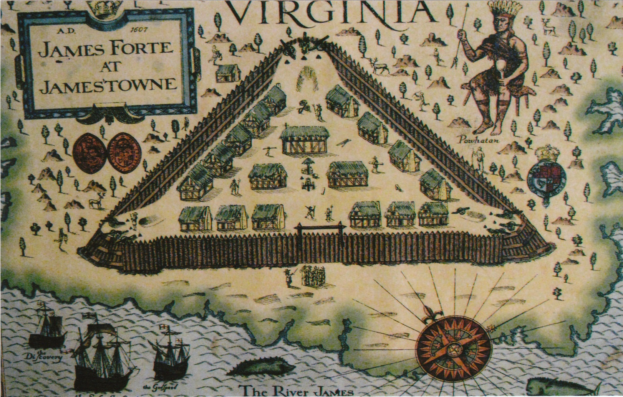

Doc 3

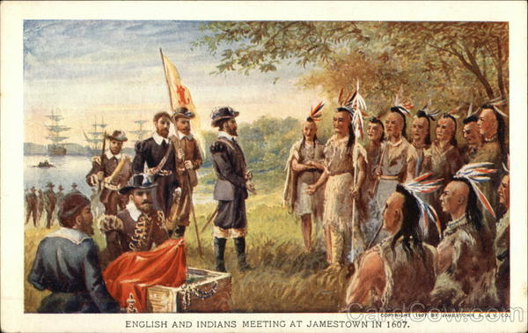

Doc 4

Our men were destroyed with cruel diseases . . . Thus we lived for the space of five months in this miserable distress. . . . It pleased God after a while to send the Indians which were our mortal enemies to relieve us with . . . bread, corn, fish, and flesh in great plenty, otherwise we had all perished.
George Percy, “Observations Gathered Out of a Discourse of the Plantation of the Southern Colony of Virginia by the English, 1606,” as quoted in Haile, pp. 99–100.

Doc 5
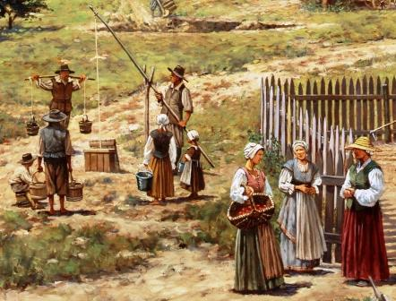

Doc 6

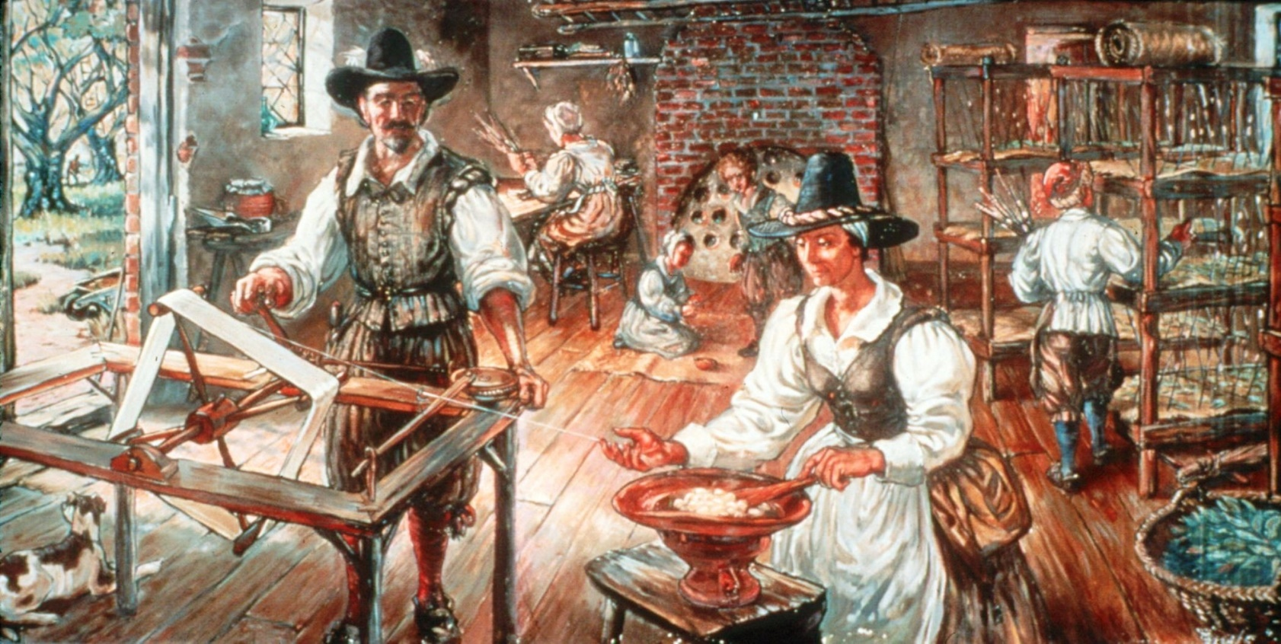

Doc 7

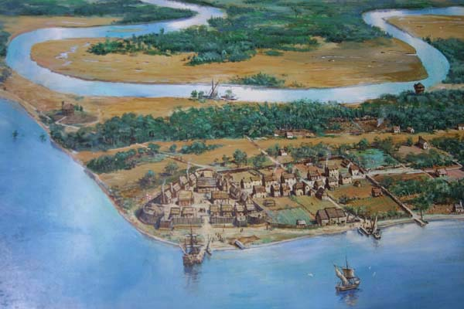
Doc 8

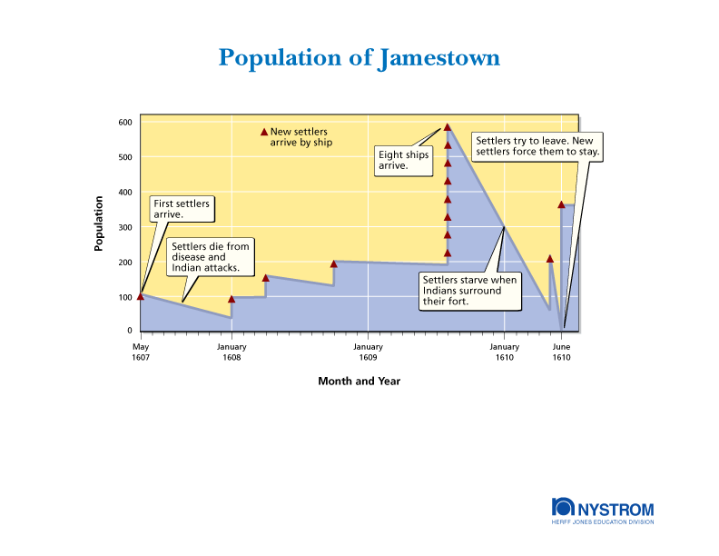

Doc 9
Laws of Jamestown Continued...
Every man and woman shall attend church service on Sunday morning and afternoon. Non attendance will result in loss of allowance and food for a whole week on the first offense. For the second offense, he or she shall lose their allowance and be whipped. For the third offense, he or she shall suffer death.

Every tradesman shall work at his trade dutifully each day or lose meals for one month for the first offense.

Anyone who robs a garden, public or private, or a vineyard, or who steals ears of corn shall be punished with death.

Doc 10
Timeline of Native American Encounters with Jamestown
May 1607- Attack by a Paspahegh Indian tribe
September 1607- John Smith was looking for food in the forest and was captured by Powhatan Indians. Powhatan wants to kill John Smith. But Pocahontas, saves him. A friendly trading relationships starts with the colonists and Indians
1608- A fire destroys Jamestown. Pocahontas brings food to the colonists.
1609- John Smith leaves Jamestown and the Indians stop trading with the colonists.
1614- On April 24, John Rolfe and Pocahontas are married. For 8 years after, there is peace between the colonists and Indians.
1622- Powhatan Indians attacked and killed over 300 colonists. Captain William Tucker and Dr. John Potts visit a Powhatan village. They gave the Indians wine as a gift. But the wine was poisoned and 200 Native Americans were killed by the poison

