Name: _______________________ Date: __________ Period: ____

MYSTERY OF THE OLMEC
By MICHAEL D. LEMONICK Sunday, June 24, 2001
More than 1,500 years before the Maya flourished in Central America, 25 centuries before the Aztecs conquered large areas of Mexico, the mysterious Olmec people were building the first great culture of Mesoamerica. Starting in 1200 B.C. in the steamy jungles of Mexico's southern Gulf Coast, the Olmec's influence spread as far as modern Guatemala, Honduras, Belize, Costa Rica and El Salvador. They built large settlements, established elaborate trade routes and developed religious rituals, including ceremonial ball games, blood-letting and human sacrifice, that were adapted by all the Mesoamerican civilizations to follow.

1. What are some of the developments of the Olmecs that other civilizations used? List 2

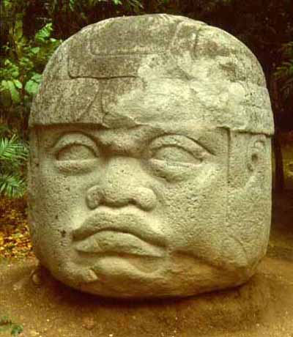
And then, about 300 B.C., their civilization vanished. No one knows why. But they left behind some of the finest artworks ever produced in ancient America. The Olmecs works of art include enormous 10-ton stone heads. These stone heads have created a lot of interest and are a huge mystery. How were they made? Why are they all that is left behind of this culture?
For historians the artworks are much more than gorgeous museum pieces. If the Olmec ever had a written language, all traces of it have disappeared. Even their bones are gone, rotted long ago in the humid rain forest. Virtually everything that scholars know about them is based on the remains of cities and on comparisons between their artifacts and imagery and those of later civilizations. It isn't surprising, therefore, that while the experts have plenty of theories about the Olmec's origins, social structure and religion, few of these ideas are universally accepted.
2. Why are these pieces of artwork so important to historians to find out about the Olmecs? Why can’t historians study the bones or writing of the Olmecs to learn about them?

What scholars do know is that the ancestors of the Olmec, like those of all Native Americans, were Asian hunter-gatherers who crossed into the Americas at least 12,000 years ago, at the end of the most recent ice age. Bits of ancient garbage and the remains of mud buildings hint that by about 2000 B.C., some of their descendants had settled in what is now the Mexican states of Veracruz and Tabasco, living in small fishing villages along the region's rivers.
3. List 3 things we do know about the Olmecs.

The most famous Olmec artifacts are 17 colossal stone heads, presumed to have been carved between 1200 B.C. and 900 B.C. Cut from blocks of volcanic basalt, the heads, which range in height from 5 ft. to 11 ft. and weigh as much as 20 tons, are generally thought to be portraits of rulers. Archaeologists still have not determined how the Olmec transported the basalt from quarries to various settlements as far as 80 miles away--and, in San Lorenzo, hoisted it to the top of a plateau some 150 ft. high. "It must have been an incredible engineering effort," Joralemon says. "These people didn't have beasts of burden, and they didn't have wheels. We don't know if they floated the blocks on rafts or traveled over land."
4. What makes the stone heads of the Olmecs so impressive? Why would they have been difficult to transport?

There is still hope that archaeologists can solve this mystery, as well as dozens of other unanswered questions about the Olmec. Most of the sites have barely been studied, and with good reason. Annual floods smother the land with thick layers of silt that dry into impenetrable clay. What's more, says Diehl, "about 80% of the entire Olmec territory in southern Mexico has been converted in the past 20 years from jungle to cow pastures and sugar-cane fields. There's so much vegetation on the surface that you can't just pick up pottery. Generally, you can't even see the ground." Beyond that, the hot, humid climate makes the work extremely unpleasant.
5. How does the location and climate of the artifacts make them difficult to study?

Final Thoughts:
6. What do you think? What could these stone heads have been used for? How did the Olmecs transport them?

Read more: http://www.time.com/time/magazine/article/0,9171,136151,00.html#ixzz2AEGakJf4

