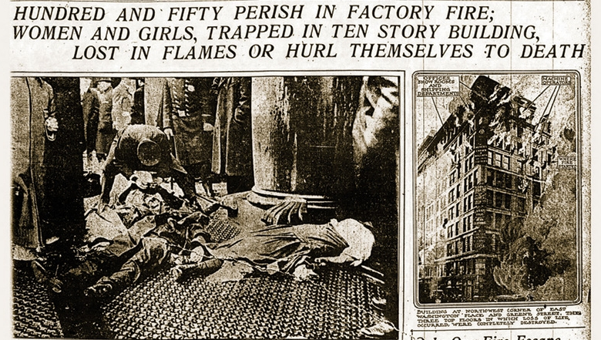
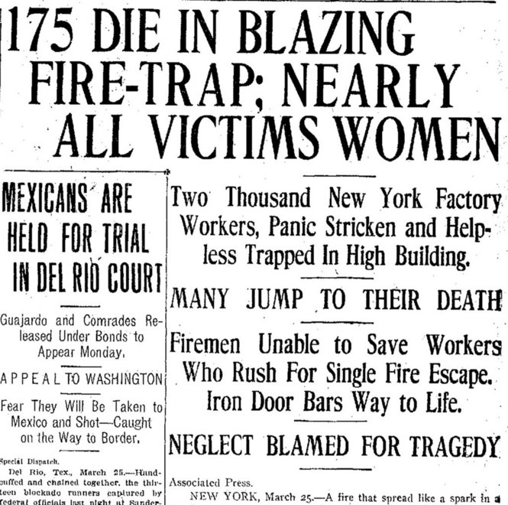
Triangle Shirtwaist Factory Fire Resource Packet: This packet contains primary sources and newspaper accounts of the events of the fire

Text from the New York Times Article about the Fire has been transcribed for you below so it is easier to read:
New York Times – March 26, 1911
Three stories of a ten-floor building at the corner of Greene Street and Washington Place were burned yesterday, and while the fire was going on 141 young men and women at least 125 of them mere girls were burned to death or killed by jumping to the pavement below.

The building was fireproof. It shows now hardly any signs of the disaster that overtook it. The walls are as good as ever so are the floors, nothing is the worse for the fire except the furniture and 141 of the 600 men and girls that were employed in its upper three stories.

Most of the victims were suffocated or burned to death within the building, but some who fought their way to the windows and leaped met death as surely, but perhaps more quickly, on the pavements below.

The victims who are now lying at the Morgue waiting for identification were employed at making shirtwaist by the Triangle Waist Company, the principal owners of which are Isaac Harris and Max Blanck. Most of them could barely speak English. Many of them came from Brooklyn. Almost all were the main support of their hard-working families. The victims mostly Italians, Russians, Hungarians, and Germans were girls and men who had been employed by the firm of Harris & Blanck, owners of the Triangle Waist Company.

There is just one fire escape in the building. That one is an interior fire escape. In Greene Street, where the terrified unfortunates crowded before they began to make their mad leaps to death, the whole big front of the building is guiltless of one. Nor is there a fire escape in the back.

A heap of corpses lay on the sidewalk for more than an hour. The firemen were too busy dealing with the fire to pay any attention to people whom they supposed beyond their aid. When the excitement had subsided to such an extent that some of the firemen and policemen could pay attention to this mass of the supposedly dead they found about half way down in the pack a girl who was still breathing. She died two minutes after she was found.

At 4:40 o'clock, nearly five hours after the employees in the rest of the building had gone home, the fire broke out. The one little fire escape in the interior was resorted to by any of the doomed victims. Some of them escaped by running down the stairs, but in a moment or two this avenue was cut off by flame. The girls rushed to the windows and looked down at Greene Street, 100 feet below them. Then one poor, little creature jumped. There was a plate glass protection over part of the sidewalk, but she crashed through it, wrecking it and breaking her body into a thousand pieces.

Then they all began to drop. The crowd yelled "Don't jump!" but it was jump or be burned the proof of which is found in the fact that fifty burned bodies were taken from the ninth floor alone.

Witness Testimonials- The accounts below are from witnesses of the events- Remember that unlike the newspaper account, these testimonials could be biased and should be read carefully

Account of Benjamin Levy- One of the first men of the scene
Benjamin was one of the first men to arrive at the burning building, says that it was all of ten minutes after the fire started before the first fire engine arrived. Mr. Levy is the junior member of the firm of I. Levy & Son wholesale clothing manufactures just around the corner, at 3 and 5 Waverley Place.

"I was upstairs in our work-room," said he, "when one of the employees who happened to be looking out of the window cried that there was a fire around the corner. I rushed downstairs, and when I reached the sidewalk the girls were already jumping from the windows. None of them moved after they struck the sidewalk. Several men ran up with a net which they got somewhere, and I seized one side of it to help them hold it.

"It was about ten feet square and we managed to catch about fifteen girls. I don't believe we saved over one or two however. The fall was so great that they bounced to the sidewalk after striking the net. Bodies were falling all around us, and two or three of the men with me were knocked down. The girls just leaped wildly out of the windows and turned over and over before reaching the sidewalk.”
One for the policemen who were checking up the bodies as they were being shipped to the Morgue told of one heap in which a girl was found still alive when the others were taken off her. She died before an ambulance doctor could reach her.
__________________________________________________________________________________________
Yetta Lublitz, female worker in the factory- Describing her experience she said:

"I never knew that there was a stairway on the Washington Place side as we never were allowed to leave on any but the Greene Street side. I was employed as an operator on the ninth floor and was about to punch my time card when I heard some one cry 'fire'."

"I saw smoke pouring up the stairs and started toward the Greene Street entrances when I noticed that there was a crowd of excited persons standing there. I then rushed to the Washington Place side, where I saw others standing about a door and trying to open it. When tried the door I could not open it.

"I started back to the Greene Street door, but saw flames coming up and changed my mind. Some burning pieces of cloth were blown about the floor and it seemed that fire was all about us. Miss Gordon was with me and she cried: 'Come on! Follow me to the roof!' We ran upstairs then to the roof."

"Did any flames touch you?" asked Max D. Steuer, counsel for the two defendants, on cross-examination.

"Yes, some of the flames reached my hair and burned it. I grabbed up a piece of cloth and put it over my head to protect it from the flames. Burning cloth was being blown about."
"You went to the roof, you said: what did you do there?" asked Mr. Steuer.
"After we reached the roof we were helped to the adjoining roof by some students from the New York University Law School."
Testimony of a firefighter at the scene
I found the fire escape on the rear of the building, which was the only one, and was entirely inadequate for the number of people employed in that building.
Q. Why were they inadequate?
A. Too small and too light, and the iron shutters on the outside of the building when opened would have obstructed the egress of the people passing between the stairway and the platform.
Q. How many people were there on the eighth floor?
A. Something over 250, as I recall it.
Q. How many sewing machines?
A. There was a cutting department, and it was partially used for machines for making fine waists. About 220 persons were on the eighth floor, all of whom escaped.
Q. How did they come to escape?
A. They went down the stairway and down the fire-escape, some of them.
Q. How about the ninth floor?
A. The loss of life was greatest on the ninth floor. There were about 310 people there.
Q. How many sewing machines?
A. 288.
Q. Now, will you tell the Commission whether or not the place was overcrowded with the machines?
A. Yes, sir. All the space that could be utilized there was utilized.
Q. Were any attempts made in that case to extinguish the fire?
A. Yes, there were. They used fire pails there, and then attempted to use the fire hose.
Q. What happened to the fire hose?
A. Well, they claimed they could not get any water to it.
Q. How about the fire pail, why did that not put out the fire?
A. They did not get enough water to put it out. It spread very rapidly. The material is very inflammable, and it travels very fast, and the conditions were there, everything, to build a fire.
Q. How many fires would you say, Marshal, could have been prevented if ordinary precautions were used?
A. You mean in the factories?
Q. Yes.
A. I am not prepared to say Mr. Elkus. I am of the opinion that the precautions that are used to safeguard these premises in the form of installation of fire extinguishing apparatus would have a tendency to keep the fires down to a small size.
_________________________________________________________________________________________
Ida Mittleman and Anna Mittleman, who worked on the ninth floor, the first called both testified that they had never seen the Washington Place door on that floor without a key in the lock, and that it was not locked to their knowledge on the day of the fire.

"Did you turn the key in the door yourself on the day of the fire and find it unlocked?" asked Assistant District Attorney Charles Bostwick while cross-examining Ida Mittleman.
"No I did not try the lock myself. I waited for the Washington Place elevator and then ran to the Greene Street side. I met a crowd of girls coming from that place, and we crowded back to the elevators on the Washington Place side. I was pushed into the elevator. Then I saw my sister and gave a scream and she got into the elevator as it was going down." "You are sure that there was a string attached to the key you saw?" "Yes, I am positive about that."
__________________________________________________________________________________________
Samuel Bernstein, brother-in-law of Blanck, the factory owner
"When I heard the cry of fire I ran toward the blaze and saw a man throwing water on it. I tried to use the hose, but it would not work. Brown, the machinist, then shouted, 'We can't get the fire out, go to the other door and get the girls out,' and he went to the Washington Place door. Then I remembered my brother and ran up the Greene Street stairs, but I couldn't see him, and I ran to the tenth floor and into the shipping room, which was all afire."
During the recital of his story the witness cried, and then went on to say that he helped Harris and Blanck out through the roof, and that he made his escape by the same means
__________________________________________________________________________________________
Blanck- Factory Owner

After identifying the machines and chairs in the courtroom as similar to those used in his shop, he said he was in charge of the selling end of the business and frequently had occasion to go from one floor to another. He said he never had a key to any door.
"I used the Washington Place door several times daily," he said.
"Was there any rule in your factory that the door on the Washington Place side should be locked before the employees left the shop?" asked Mr. Steuer.
"No, there was no such rule. I was in the shipping room when I heard of the fire. First I heard a man say 'The taxi has come.' My two children were in the shop. My wife had gone South, and I intended to take them shopping. I had forgotten about them until I heard that the taxi had come.
"As I was going back to the office to get the children some one said there was a little fire down on the eighth floor. I got the children and ran to the elevator on the Washington Place side. All the pressers were crowding around there. One of my little girls got into the elevator with the crowd, but I pulled her back again and told the man to come back as soon as he could.
"I waited for a while, but the elevator didn't come back, and I took the children and went to the Washington Place door. I opened it and saw that the stairs were full of fire and smoke. I came back into the loft and shut the door behind me. I heard Harris shouting 'To the roof, to the roof,' and we ran up there. A man carried one of my little girls for me."
______________________________________________________________________________________

