Name: __________________________ Date: ____________
Warm Up
1. Which side won World War I?

2. Which side lost World War I?

3. Which country was most affected by World War I (casualties, property damage, money spent)?

4. What effects did the Treaty of Versailles have?

Name: __________________________ Date: ____________
Warm Up
1. Which side won World War I?

2. Which side lost World War I?

3. Which country was most affected by World War I (casualties, property damage, money spent)?

4. What effects did the Treaty of Versailles have?

Exit Slip
What were the causes of World War II? (You need to mention at least two.)

Exit Slip
What were the causes of World War II? (You need to mention at least two.)

Station One (World War II Basics)

Find Germany. Color it in on the map. Read about the following events and follow the directions.

Event #1 (March 1938)
Hitler threatened to invade Austria, so the Austrian Prime Minister scheduled a national vote on the issue, allowing Austrians to decide whether or not they wanted to join Germany. Before the vote could be held, German troops invaded and forced the resignation of the Prime Minister. Later, in the rescheduled vote, 98% of Austrians voted to join Germany.

Find Austria on the map, and color it the same color as Germany, to form one country.

Event #2 (September 1938)
Germany decided to reunite with Sudetenland, a section of Czechoslovakia that was mostly populated by native-speaking Germans. Hitler argued that this was justified because the citizens are true Germans and wanted to be reunited with Germany. He was prepared to invade, but through negotiations with Britain and France (but not Czechoslovakia), it was agreed that Sudetenland would be ceded to Germany.

Find the part of the map with the number 2 on it. Color that section with the same color to create a unified country.

Event #3 (September 1939)
Germany invaded Poland to reunify Germany with Danzig (a German controlled area separated by Poland). Britain and France declared war on Poland a few days later.

Find Poland on the map and color it the same color, so that you have one big country, all under German control.

Station Two (Appeasement)

1st Scenario
March 16, 1935
Hitler announces that he is rearming Germany. He has created the Luftwaffe (an air force) with 800 planes, and he says his goal is to create an army of 500,000 men. Britain negotiates a naval deal with the German navy, without consulting other countries. This deal allows the German navy to grow.

2nd Scenario
March 7, 1936
France and other Allied troops have been occupying the demilitarized zone of the Rhineland, on the border of Germany. By 1930, they leave. Hitler sends troops into the Rhineland, arguing that leaving it undefended leaves Germany open to attack.

3rd Scenario
March 1938
Hitler asserts that many Germans in Austria want to unite with Germany. After putting pressure on the Austrian government, a national vote (about whether to combine Austria with Germany) is scheduled. Blocking the vote, Germany invades and assumes control of the Austrian government, creating a unified country.

4th Scenario
September 1939
Germany invades Poland to reunify Germany with Danzig (a German controlled area separated by Poland), rejecting any attempts at peace talks.

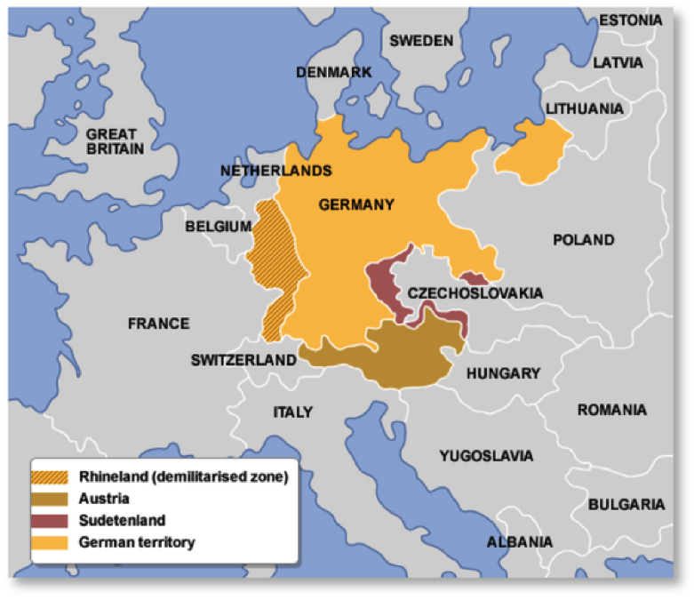

Appease (verb): To stop someone’s anger by giving in to his/her demands.

It wasn’t until the invasion of Poland that Britain and France declared war on Germany. The strategy they practiced was referred to as “appeasement.” These cartoons are about appeasement. Study them to understand the strategy.

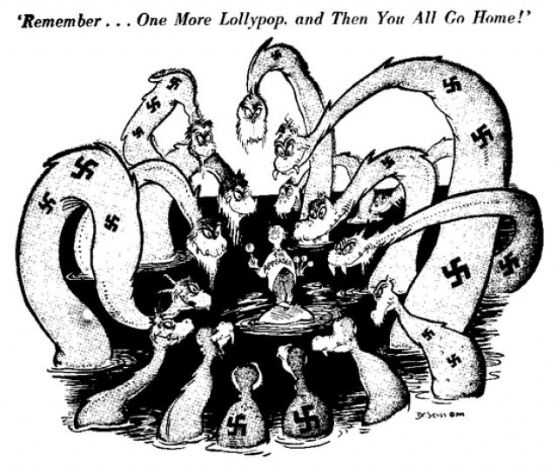
1
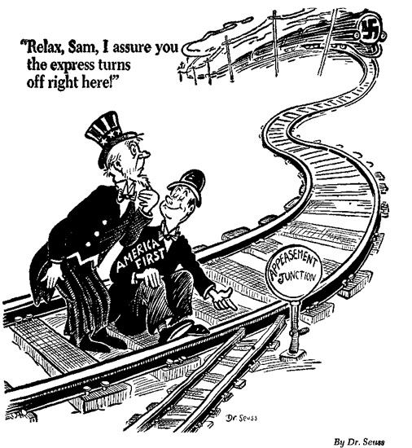
2

STATION 3 (Rise of Hitler)
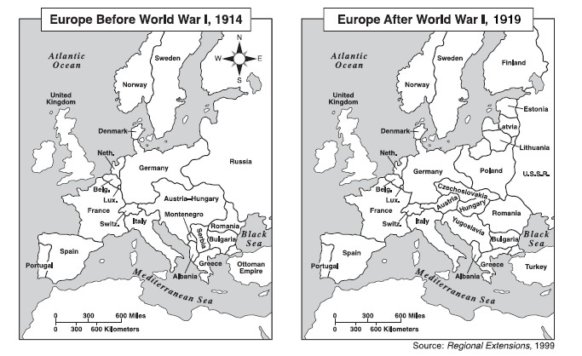

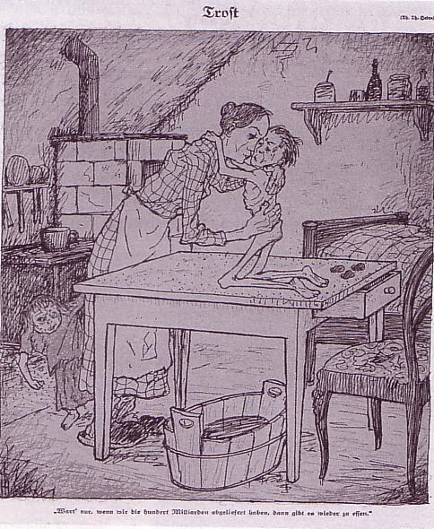
“When we have paid one hundred billion marks then I can give you something to eat.”
Translation from German cartoon, 1919

German Political Party Platforms

SOCIAL DEMOCRATIC PARTY PLATFORM
- We will honor all of Germany’s obligations, political and financial, in order that Germany’s honor and respect will not be decreased in the eyes of the world.
- We plan to create more jobs by undertaking an extensive program of public works.
- We believe in the right of those who disagree with the party to speak and write on those issues without interference.

COMMUNIST PARTY PLATFORM
We favor:
- The government can take over the land and distribute it for the common good.
- To the German people: The cause of your misery is the fact that French, British, and American capitalists are exploiting German workers to get rich themselves.

NATIONAL SOCIALIST GERMAN WORKERS PARTY PLATFORM
We demand the following:
- Abolition of the Treaty of Versailles.
- Return lands lost in World War I and colonies to give German adequate living space.
- German blood as a requirement for German citizenship. No Jew can be a member of the nation.
- Guarantee for jobs and benefits for workers.

